**EDA**

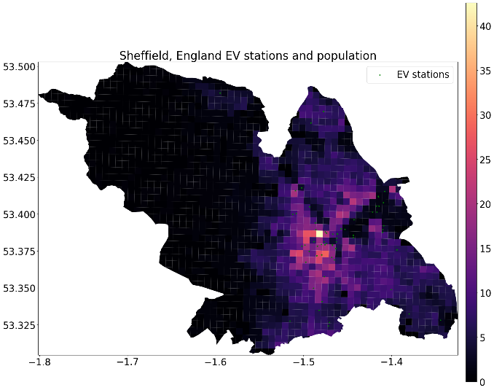

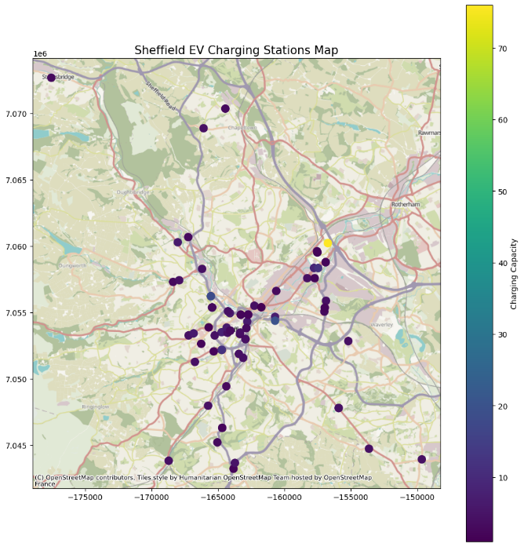

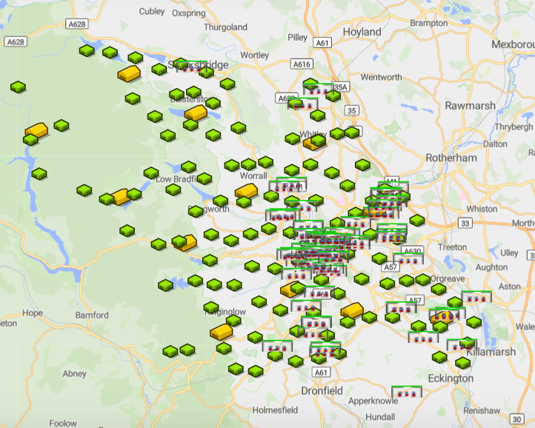

**UI/UX**

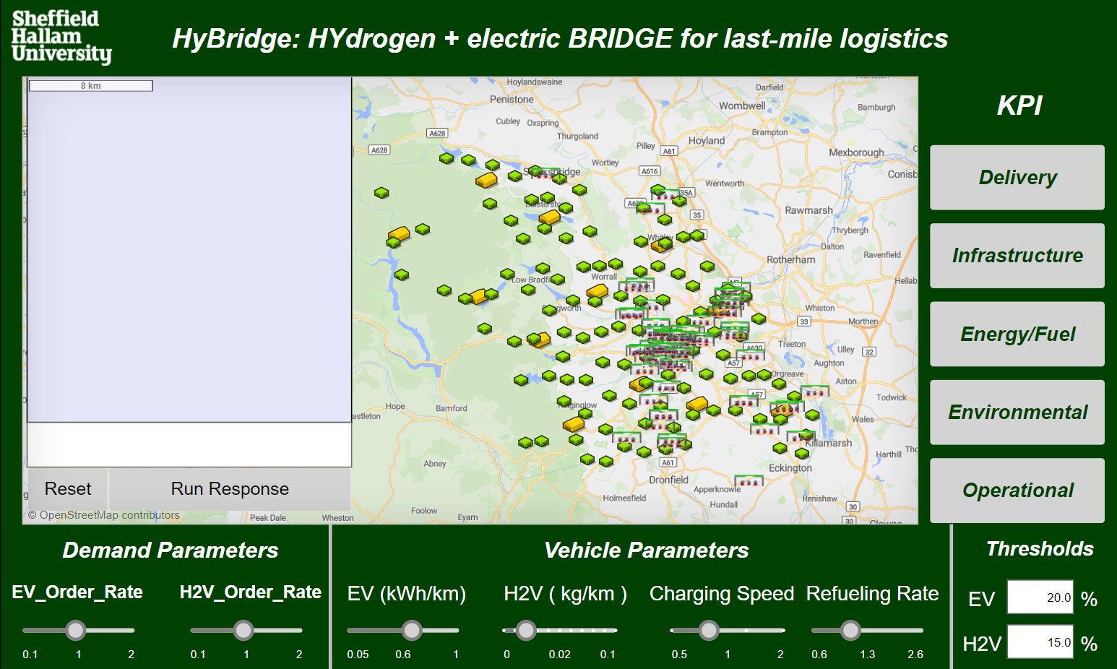

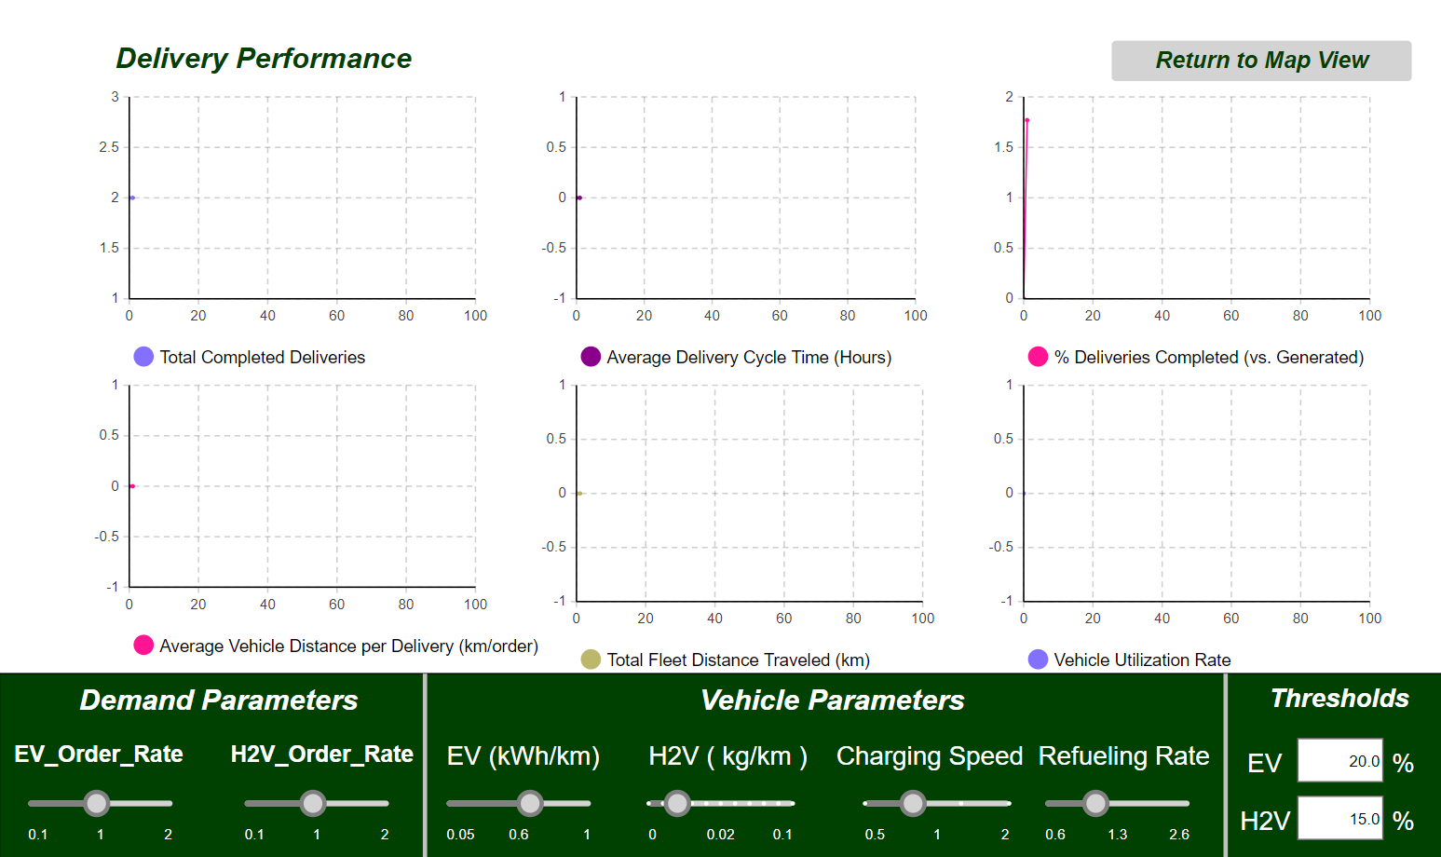

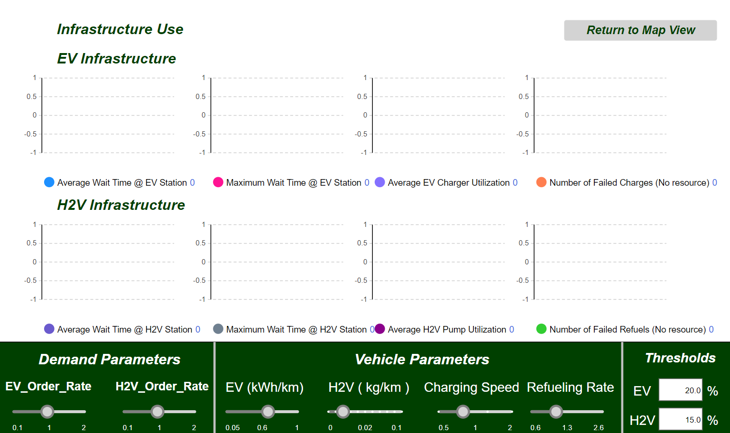

HyBridge_Infrastructure_KPI

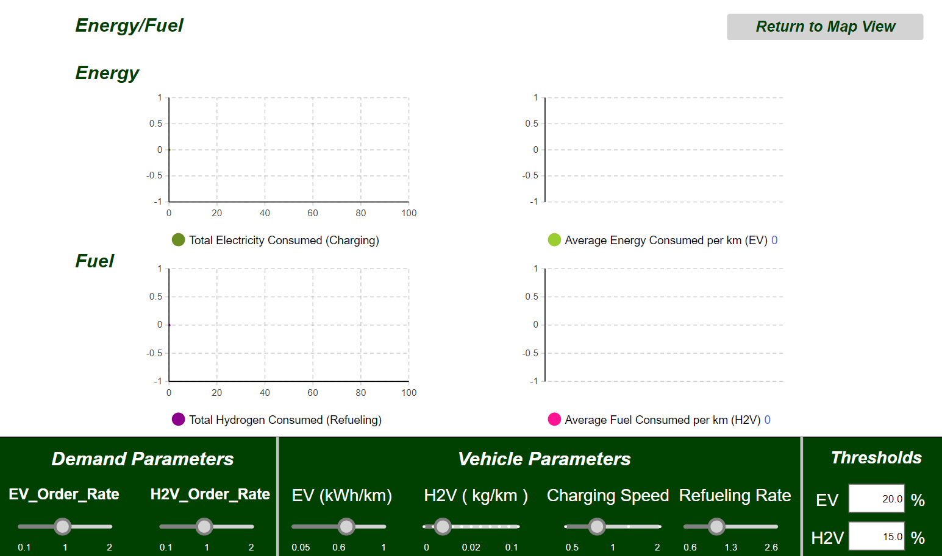

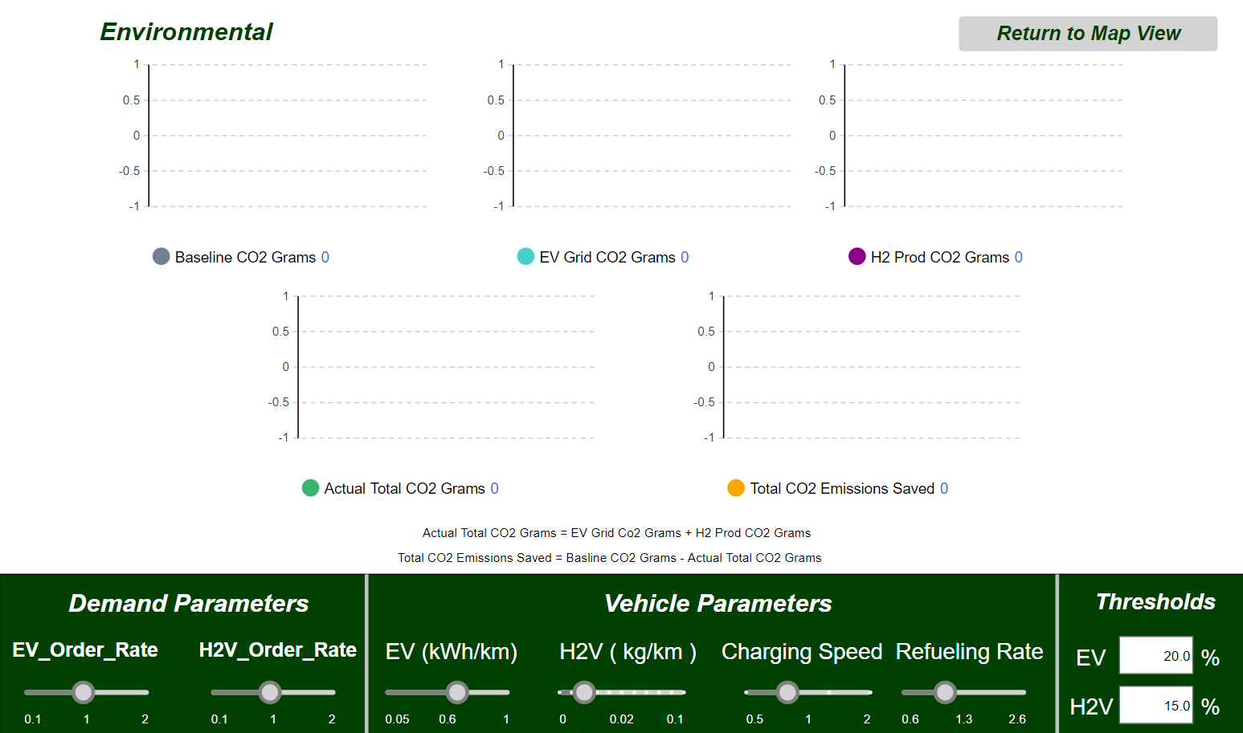

HyBridge_Environmental_KPI

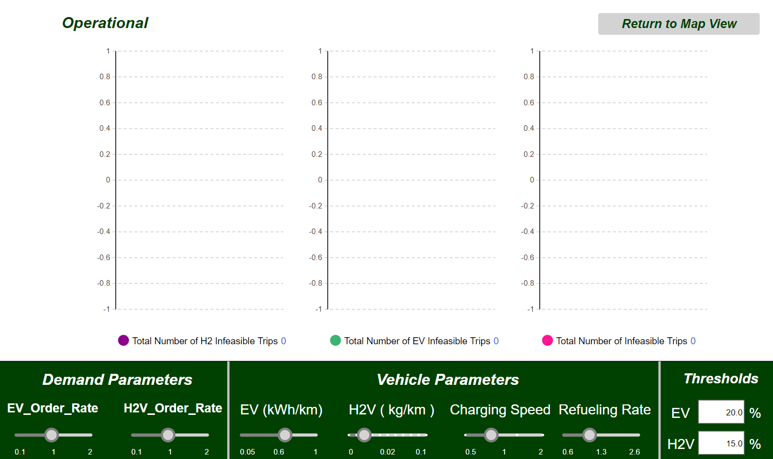

**To minimise average cycle time**

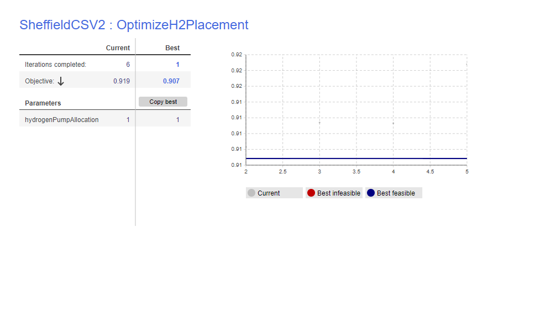

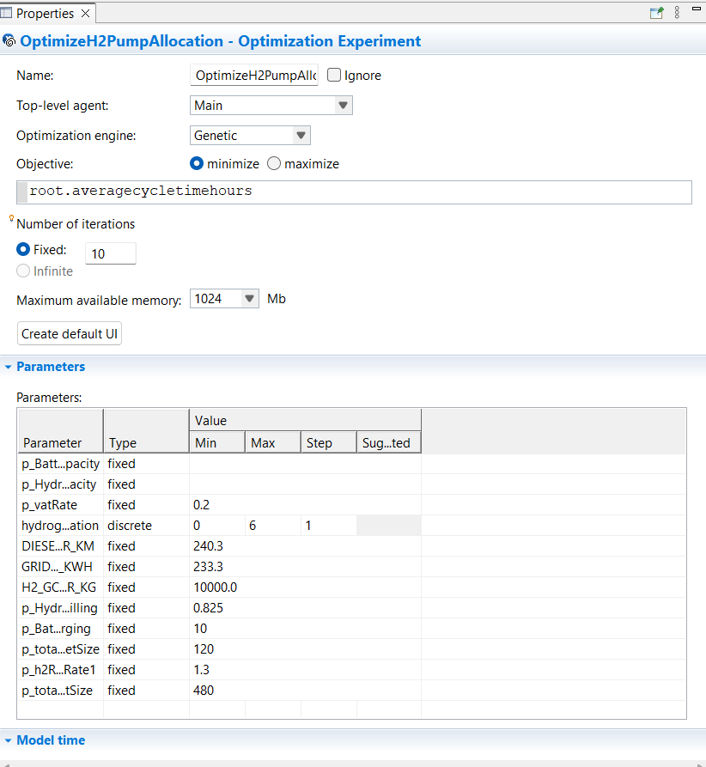

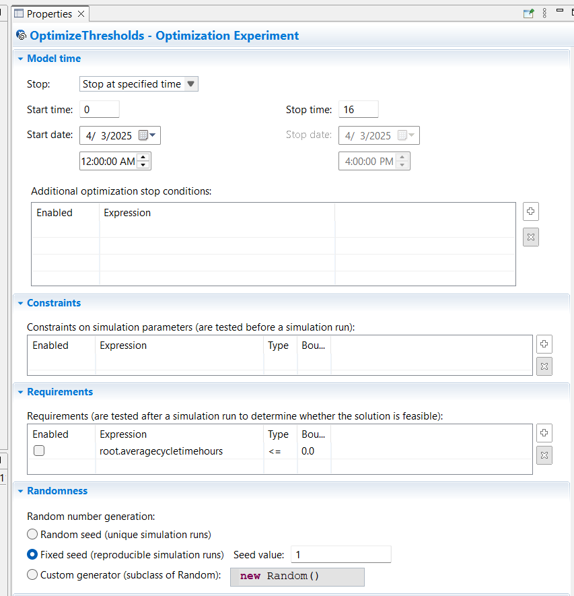

**To minimise average cycle time**

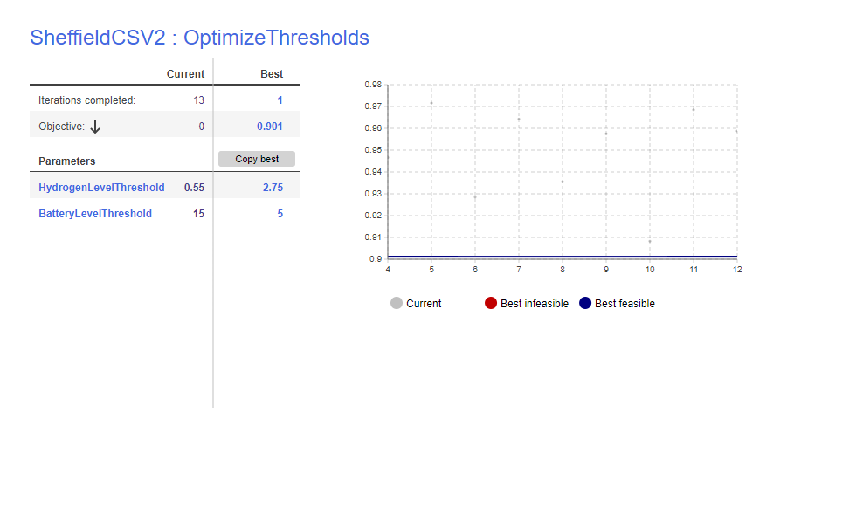

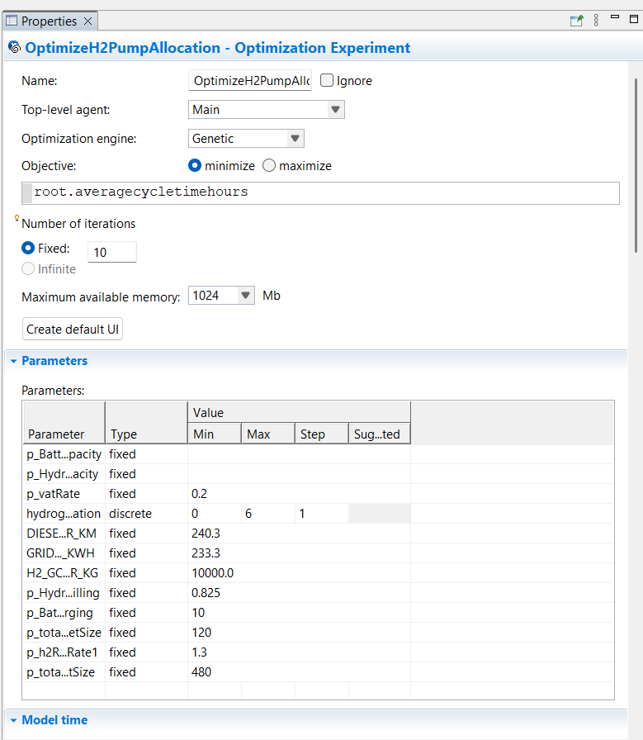

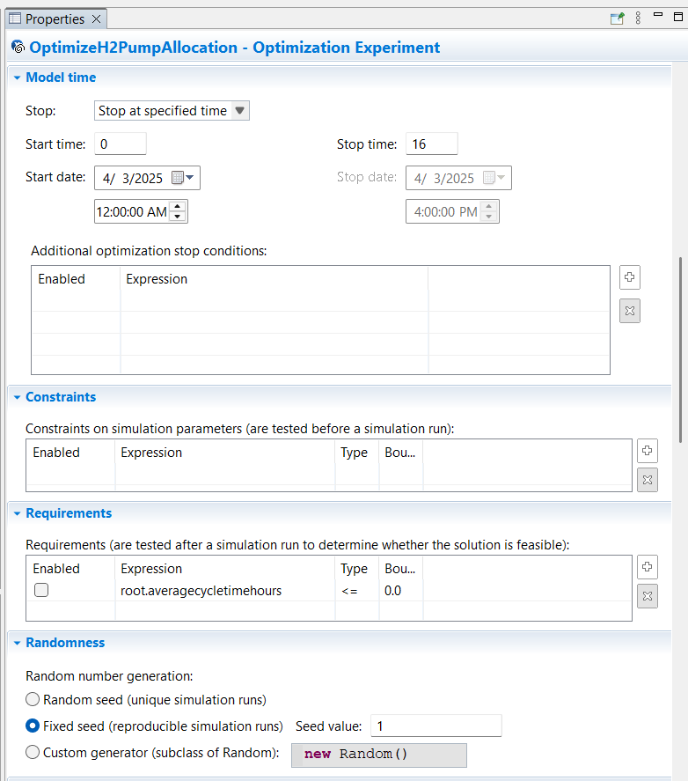

**To minimise infeasible trips**

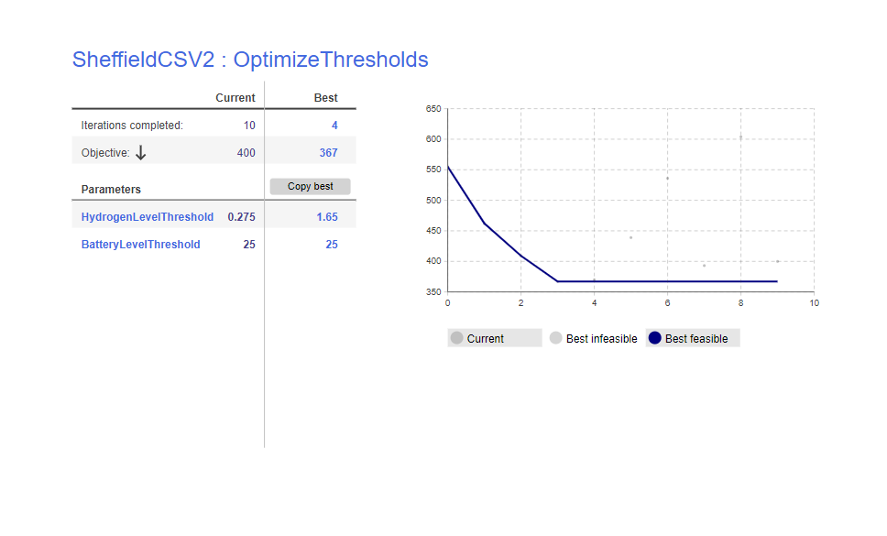

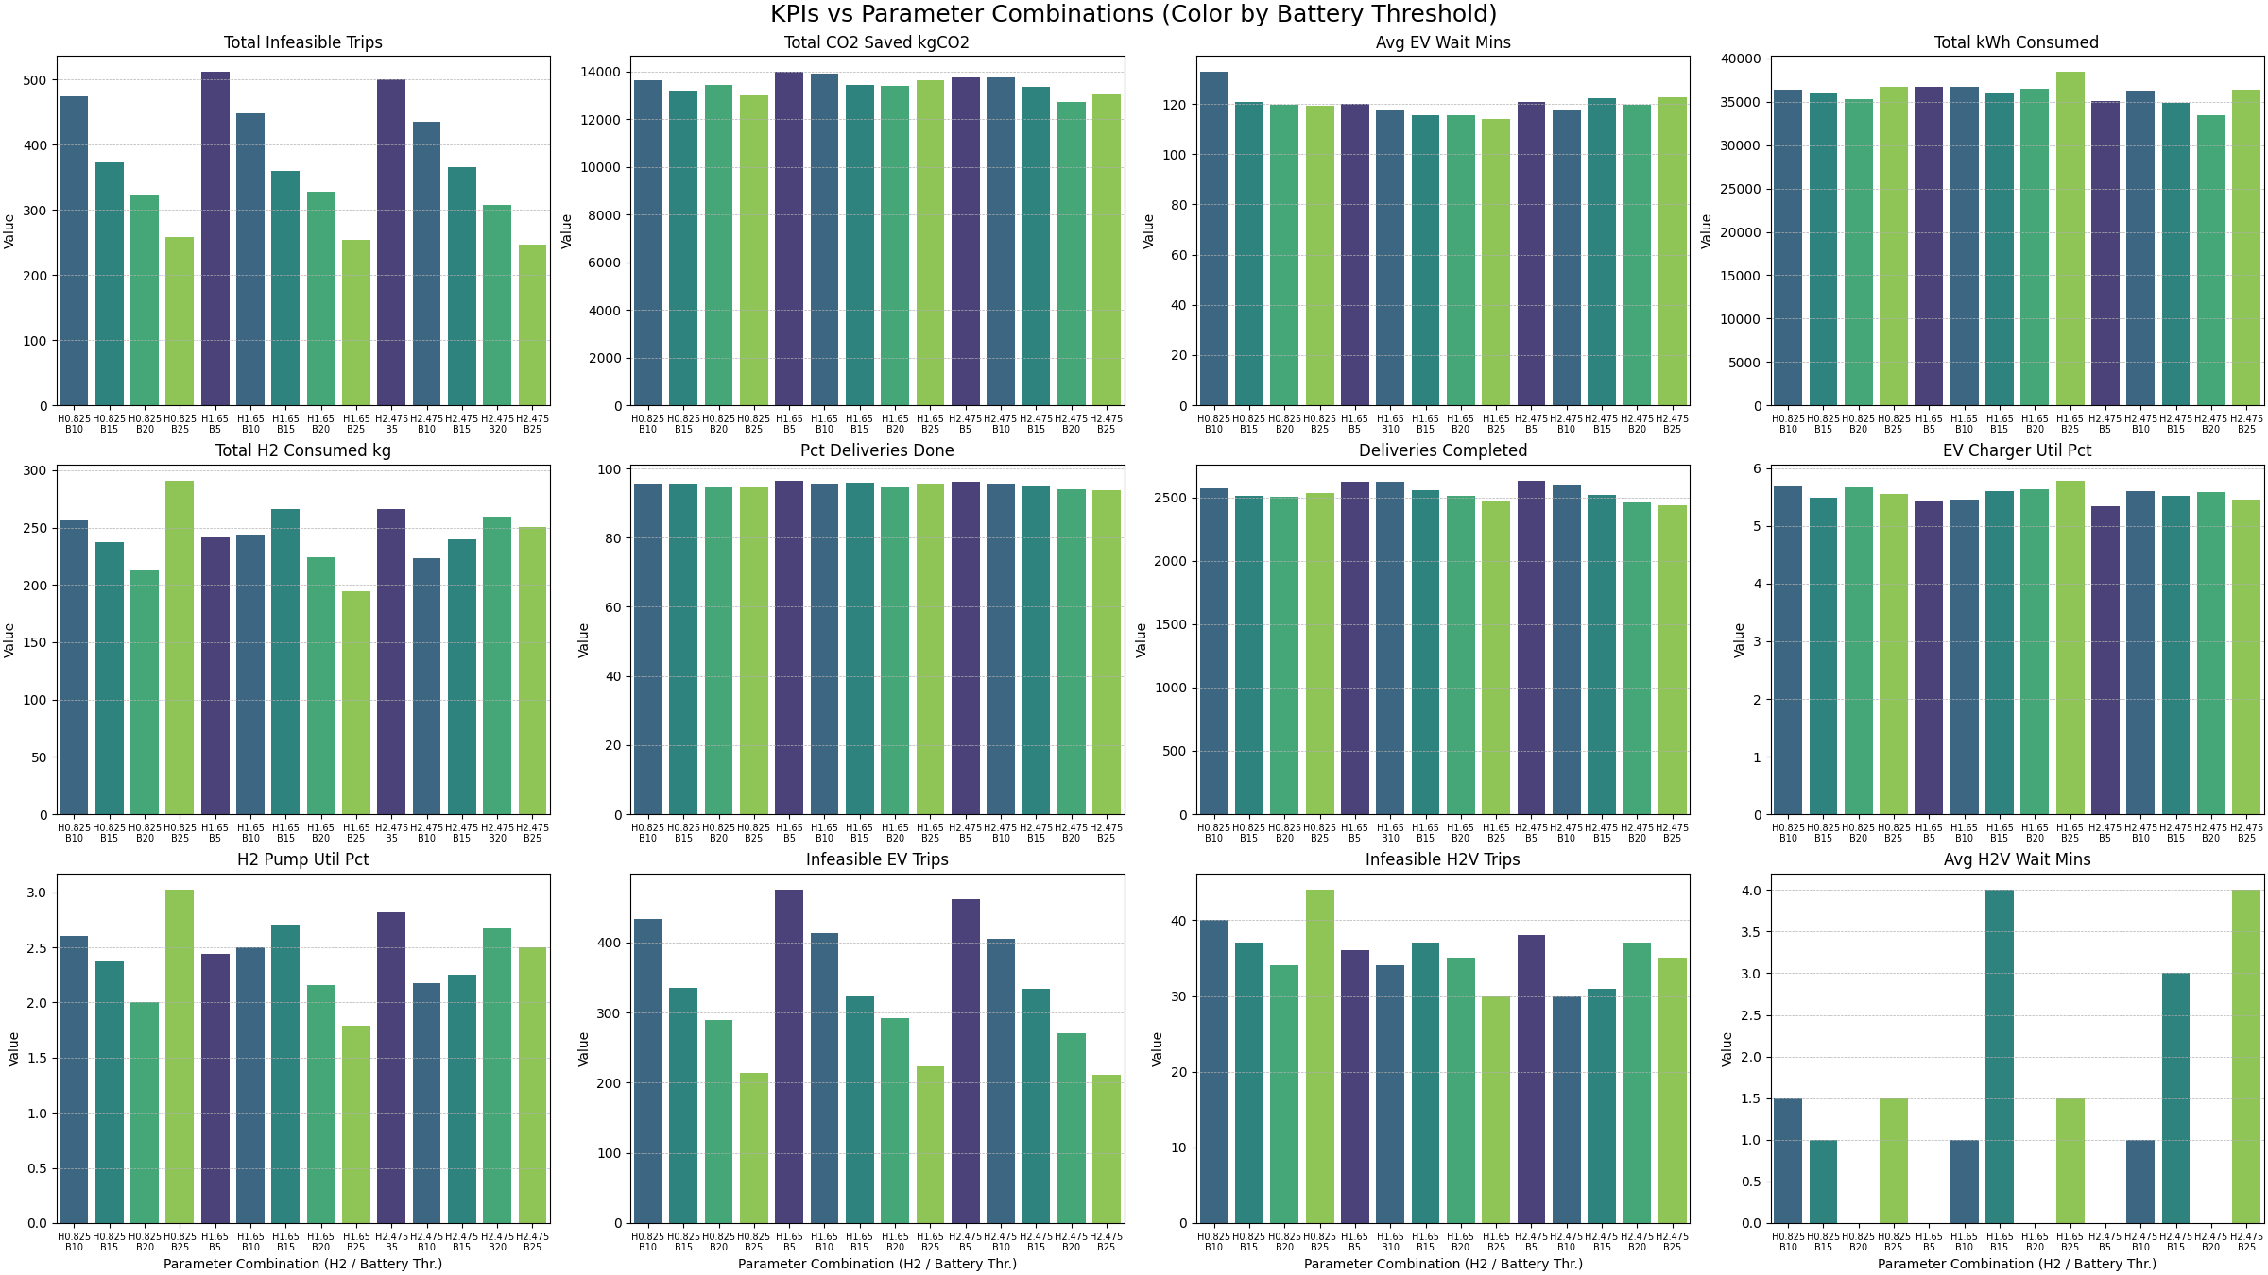

|  |  |  |  |  |  |  |  |  |
| --- | --- | --- | --- | --- | --- | --- | --- | --- |
| H2 Thr. | Batt Thr. (%) | Deliveries | Delivered (%) | Infeas. Trips | CO2 Saved (kg) | Avg EV Wait (min) | Total kWh | Total H2 (kg) |
| 0.825 | 10 | 2574 | 95.5 | 474 | 13632 | 132.6 | 36425 | 256.5 |
| 0.825 | 15 | 2516 | 95.5 | 373 | 13205 | 120.9 | 35979 | 237.1 |
| 0.825 | 20 | 2508 | 94.5 | 323 | 13435 | 119.6 | 35296 | 213.1 |
| 0.825 | 25 | 2536 | 94.4 | 258 | 12987 | 119.5 | 36676 | 290.6 |
| 1.65 | 5 | 2627 | 96.4 | 511 | 13966 | 120.1 | 36756 | 241.2 |
| 1.65 | 10 | 2624 | 95.7 | 448 | 13912 | 117.4 | 36702 | 244.3 |
| 1.65 | 15 | 2560 | 96 | 360 | 13424 | 115.4 | 35937 | 266.1 |
| 1.65 | 20 | 2512 | 94.6 | 327 | 13392 | 115.4 | 36523 | 224.5 |
| 1.65 | 25 | 2465 | 95.3 | 254 | 13631 | 114 | 38422 | 194.1 |
| 2.475 | 5 | 2629 | 96.3 | 500 | 13765 | 120.9 | 35049 | 266.3 |
| 2.475 | 10 | 2595 | 95.7 | 435 | 13737 | 117.4 | 36295 | 223.6 |
| 2.475 | 15 | 2518 | 95 | 365 | 13363 | 122.2 | 34867 | 240 |
| 2.475 | 20 | 2458 | 94.1 | 308 | 12715 | 119.5 | 33501 | 259.6 |
| 2.475 | 25 | 2441 | 93.8 | 246 | 13021 | 122.7 | 36406 | 250.3 |

**Compare Runs**

Basline

EV 80% = 480

H2V 20% = 120

Pumps = 0 per station  
  
thresholds

Battery 20% = 10

Tank 15% = 0.825

Ran for 5 days

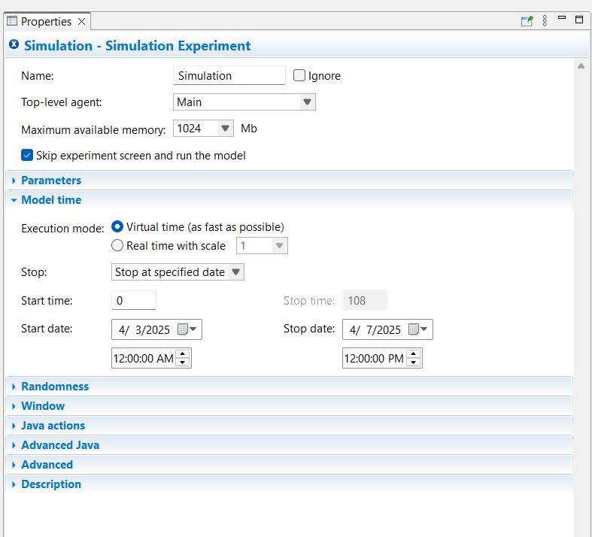

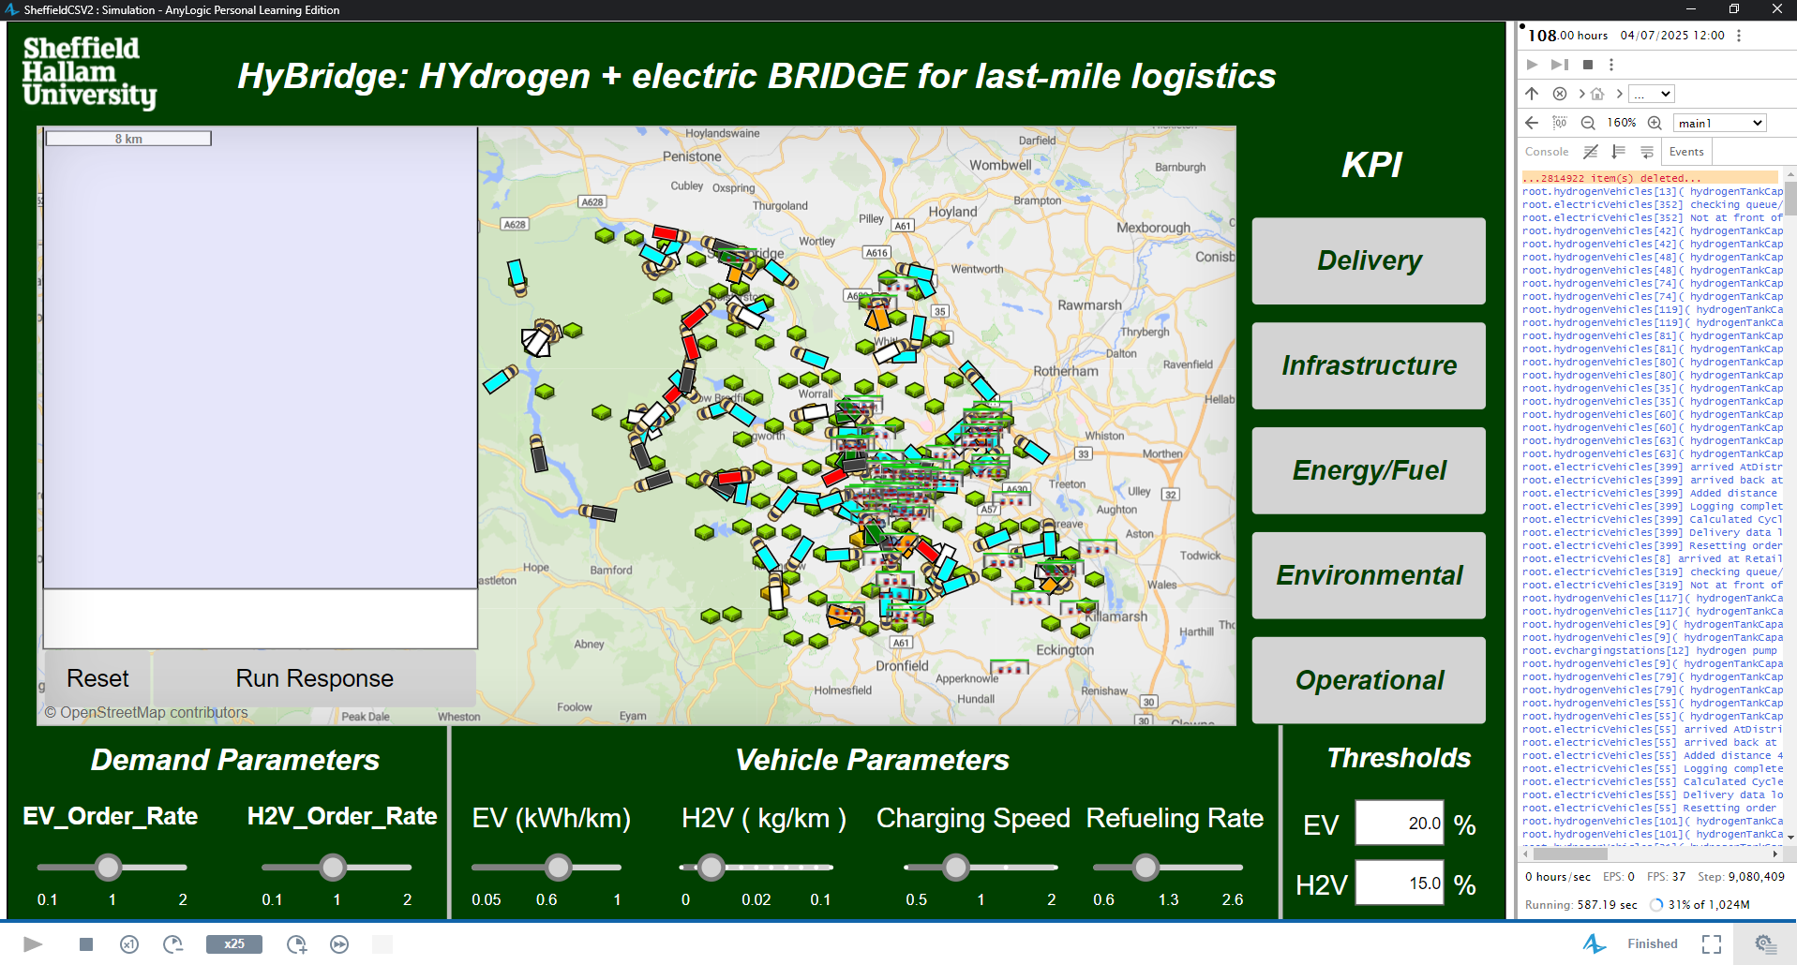

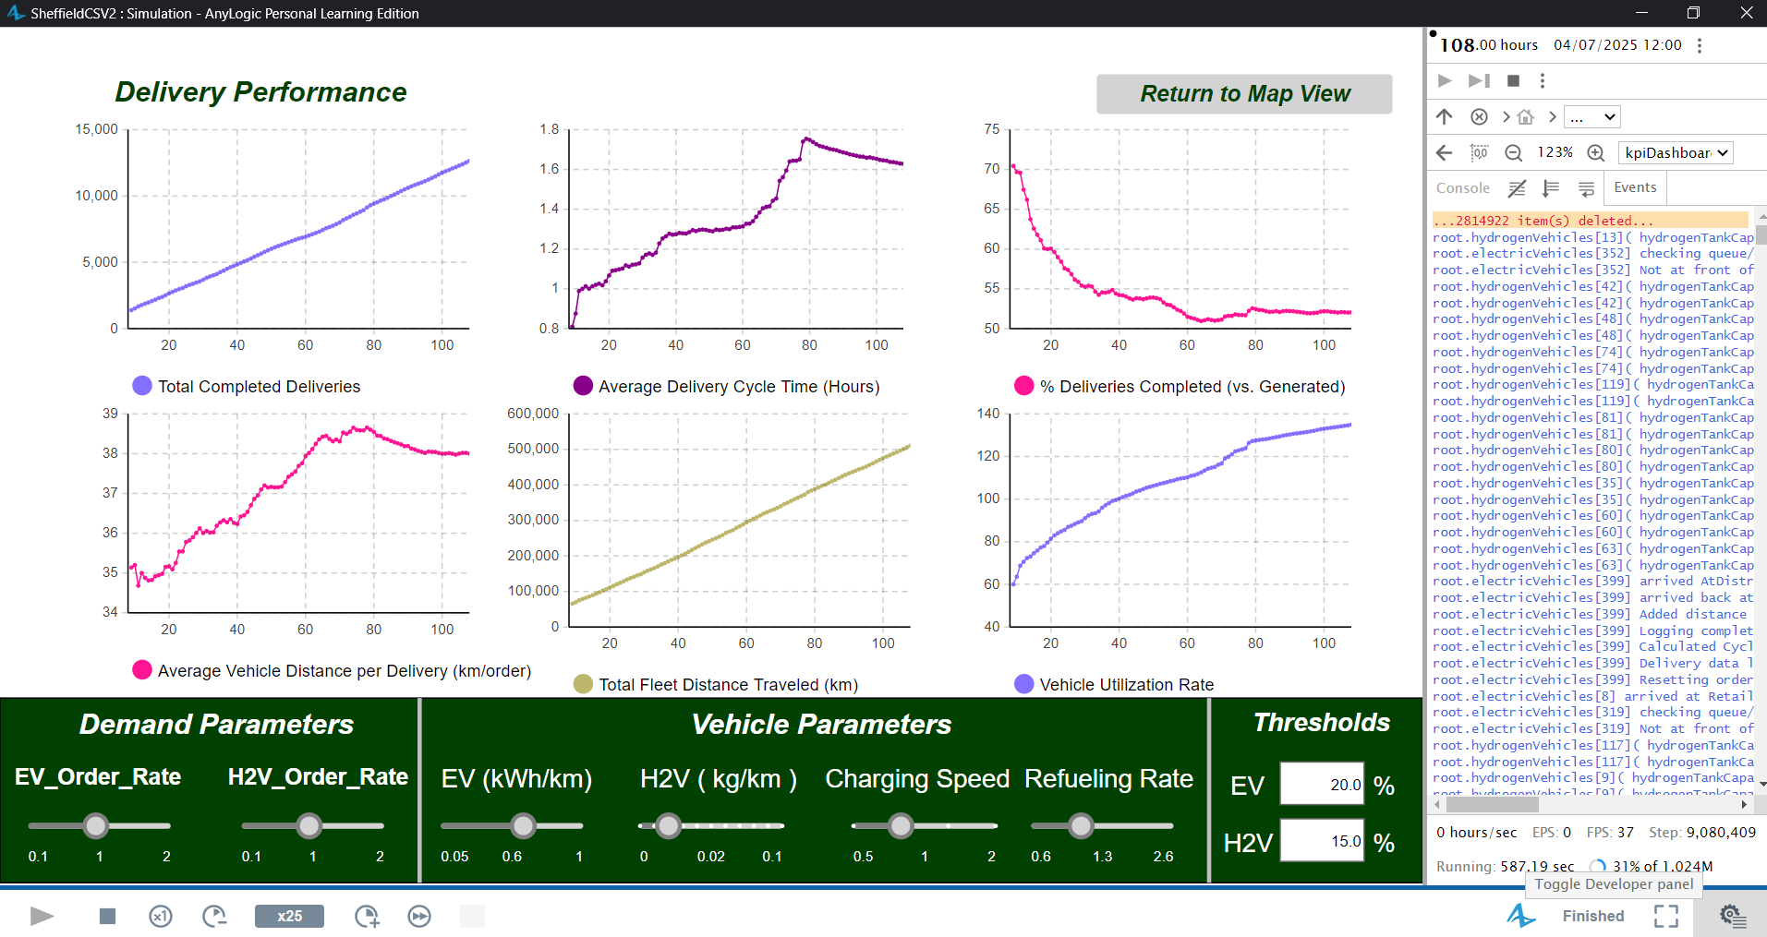

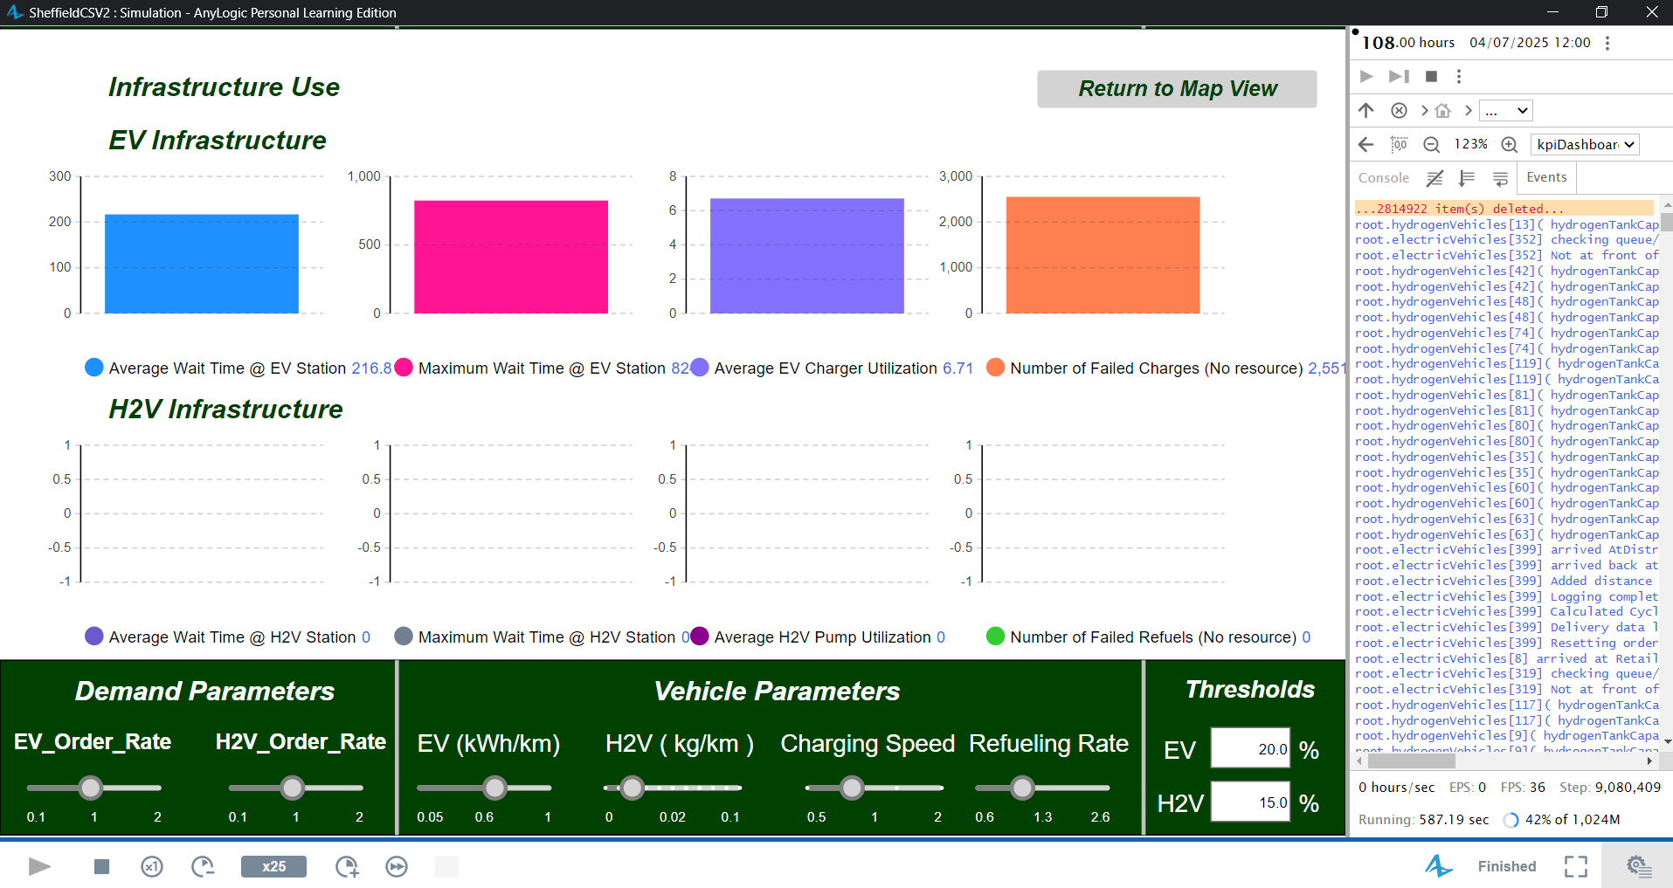

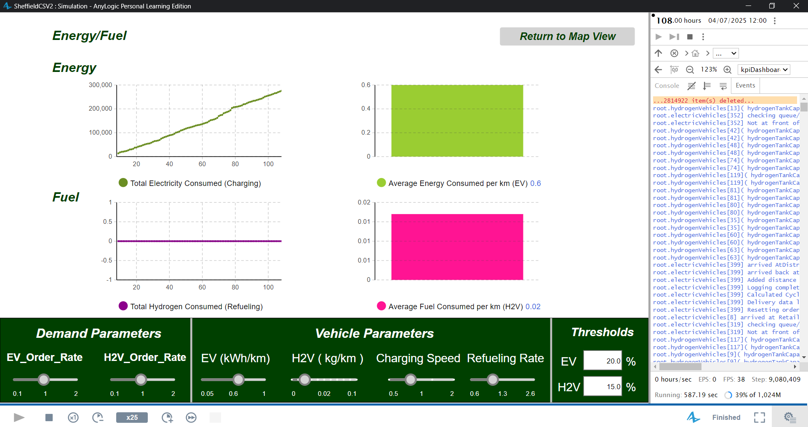

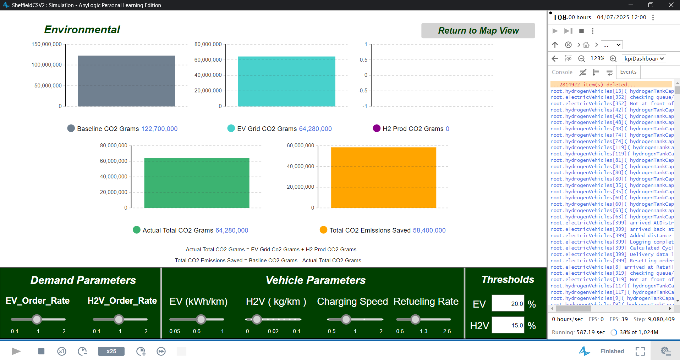

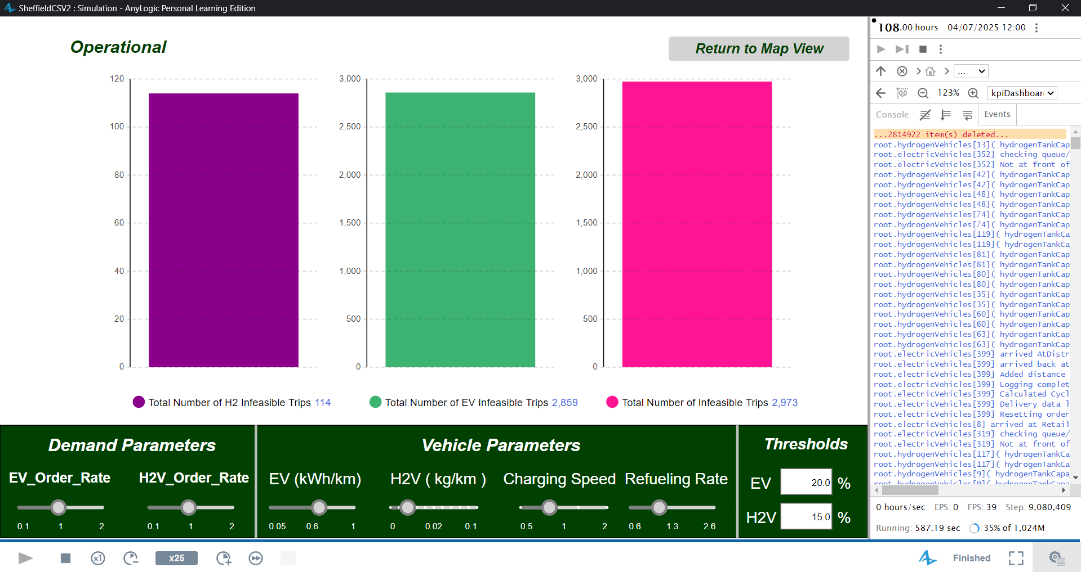

======================================================

HyBridge SIMULATION FINAL KPI REPORT

======================================================

--- Delivery Performance ---

Total Deliveries Completed: 12652

Average Delivery Cycle Time: 1.629 Hours

% Deliveries Completed: 52.04%

Average Vehicle Distance per Delivery: 38.002 km/order

Total Fleet Distance Traveled: 510,531.656 km

Overall Vehicle Utilization Rate: 134.939% (Time Active)

--- Infrastructure Use ---

Average EV Wait Time (Queuers Only): 216.811 Minutes

Maximum EV Wait Time: 824 Minutes

Average H2V Wait Time (Queuers Only): 0 Minutes

Maximum H2V Wait Time: 0 Minutes

Average EV Charger Utilization: 6.711 %

Average H2V Pump Utilization: 0 %

Number of Failed EV Charges (No resource on arrival): 2551

Number of Failed H2 Refuels (No resource on request): 0

--- Energy/Fuel Consumption ---

Total Electricity Consumed (Charging): 275,508.926 kWh

Total Hydrogen Consumed (Refueling): 0 kg

Average EV Driving Consumption: 0.6 kWh/km

Average H2V Driving Consumption: 0.017 kg/km

--- Environmental Impact ---

Baseline Diesel Emissions (est.): 122,680.757 kg CO2

EV Grid Electricity Emissions (est.): 64,276.232 kg CO2

H2 Production Emissions (est.): 0 kg CO2

Total Actual Emissions (Grid + H2 Prod.): 64,276.232 kg CO2

Estimated Total CO2 Saved: 58,404.525 kg CO2

--- Operational ---

Number of Infeasible EV Trips (Range Limit): 2859.0

Number of Infeasible H2V Trips (Range Limit): 114

Total Infeasible Trips (Range Limit): 2973.0

======================================================

END OF SIMULATION REPORT

======================================================

**Compare Runs**

**optimized**

EV 80% = 480

H2V 20% = 120

Pumps = 1 per station  
thresholds

Battery 10% = 5

Tank 50% = 2.75

Ran for 5 days

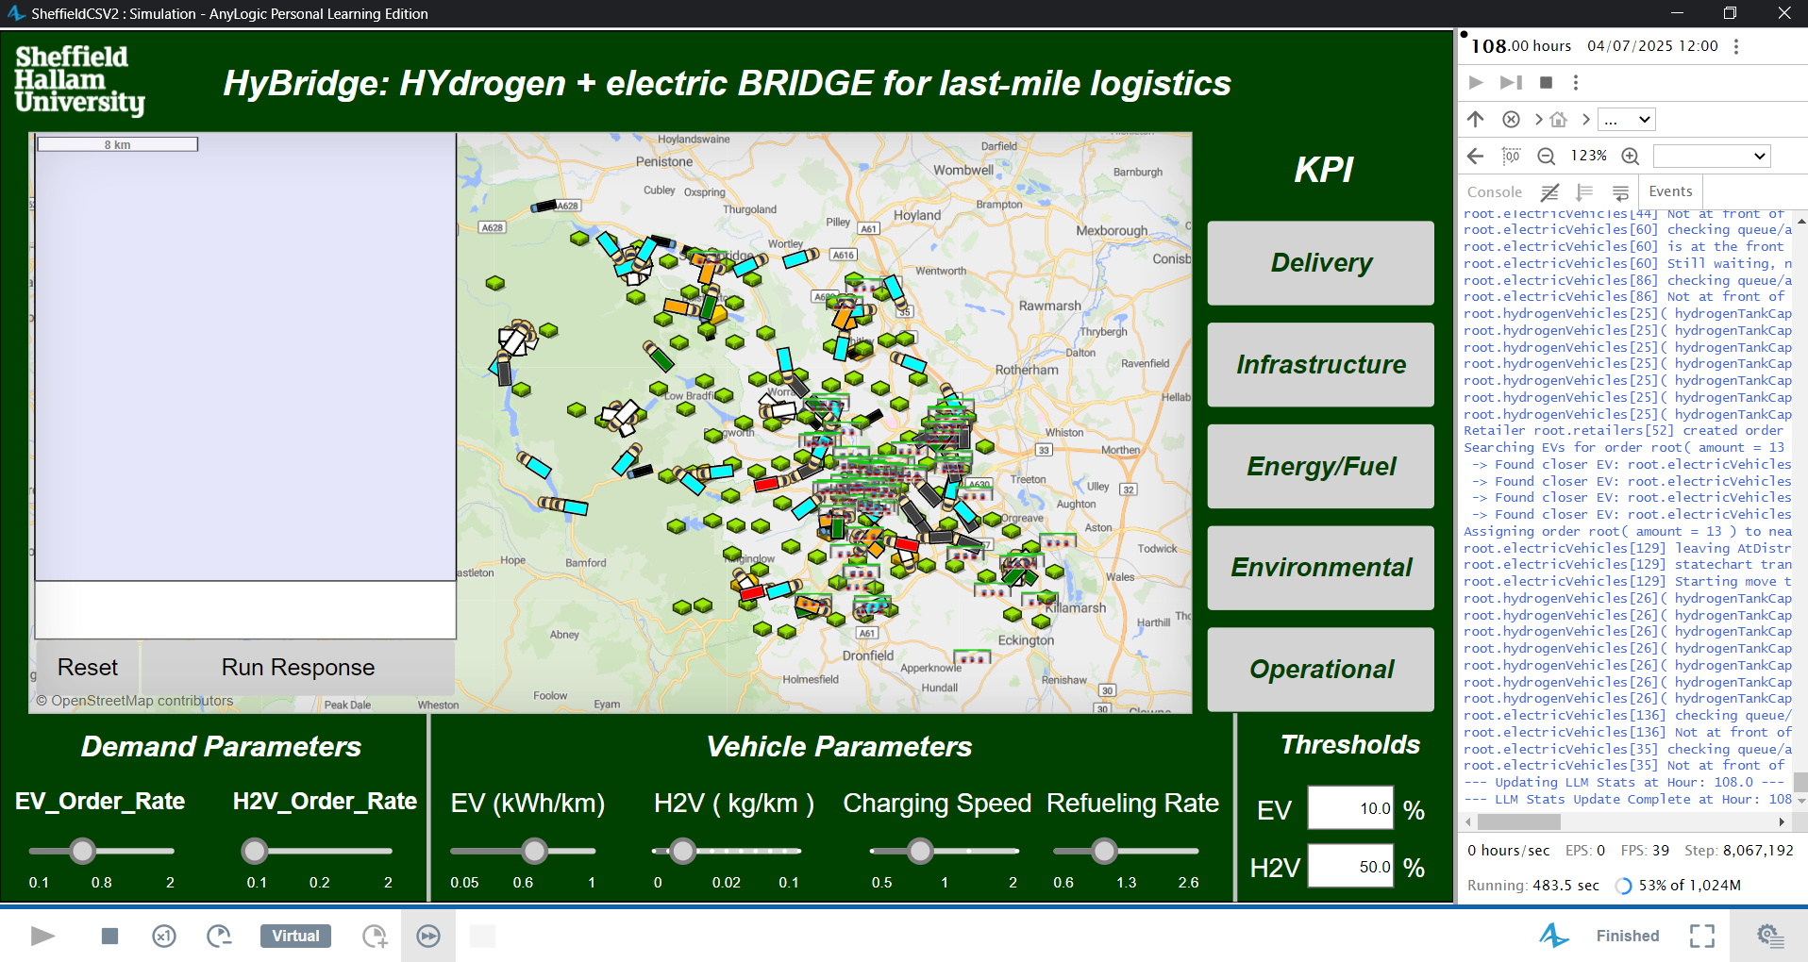

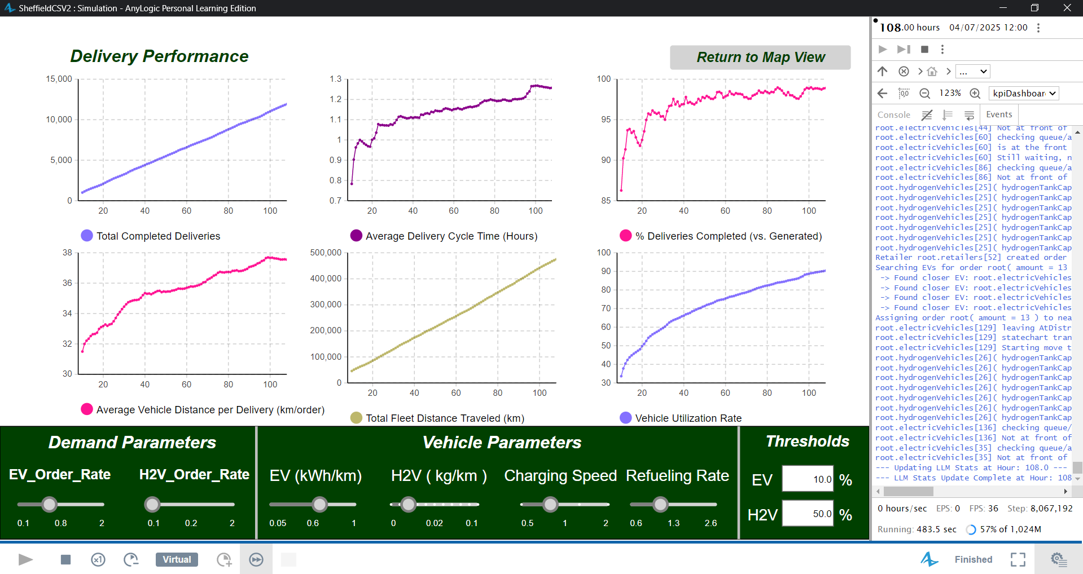

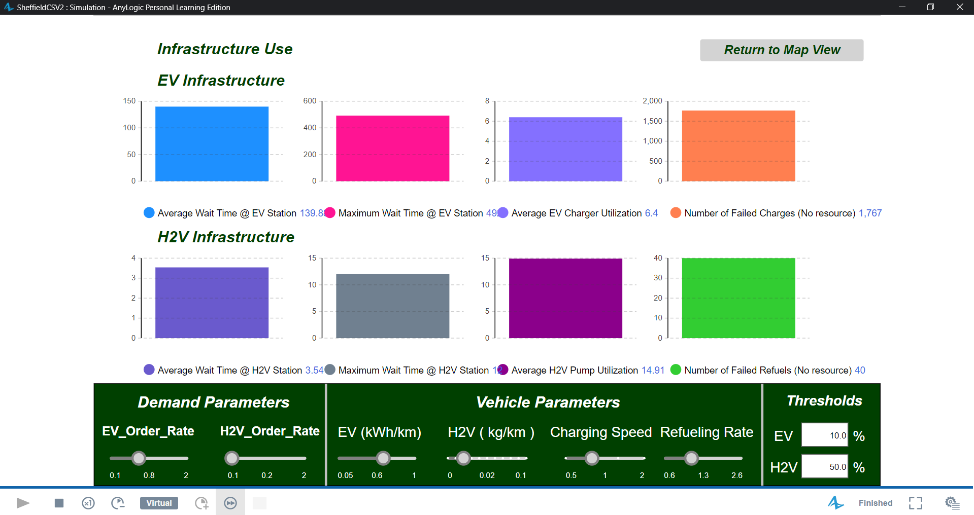

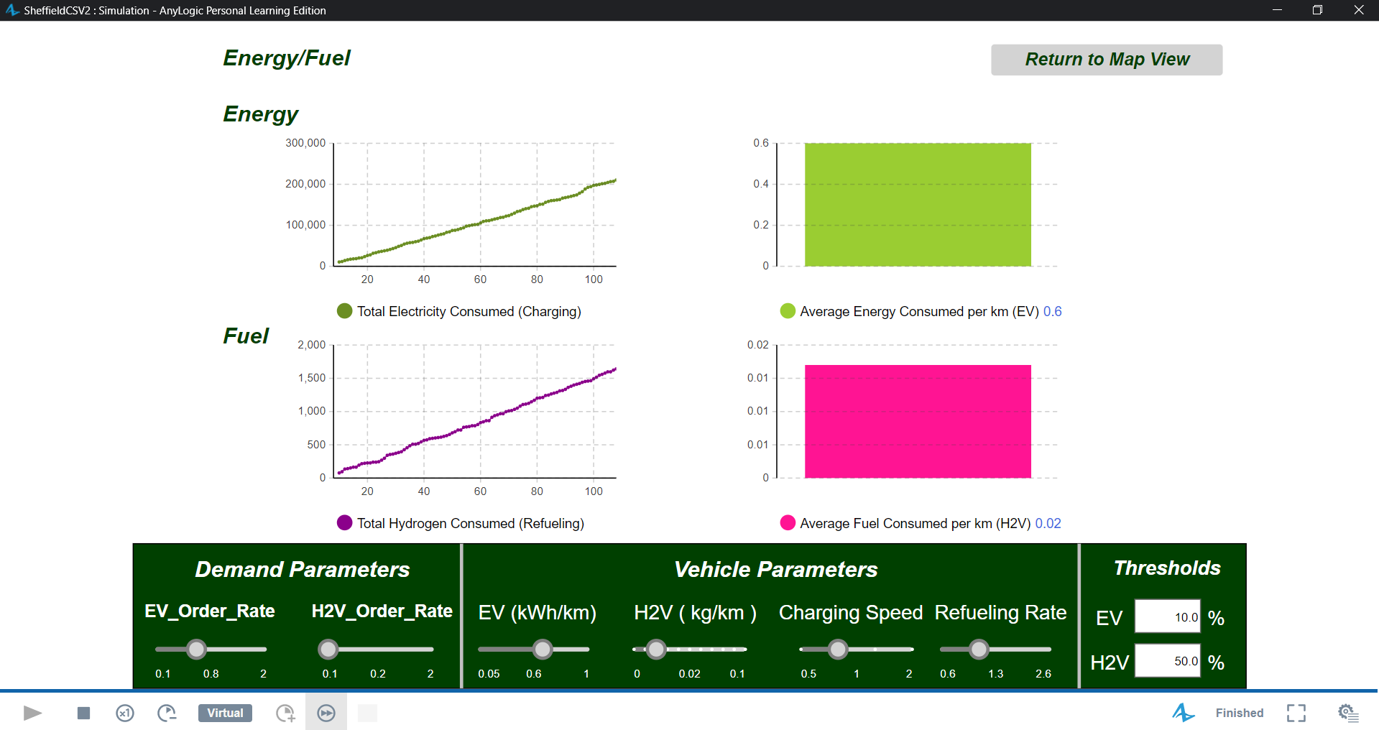

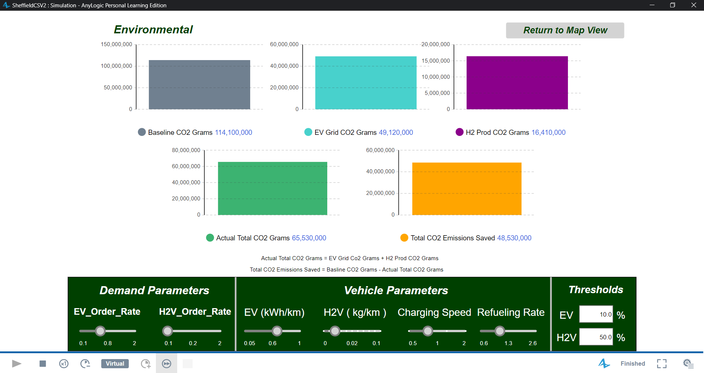

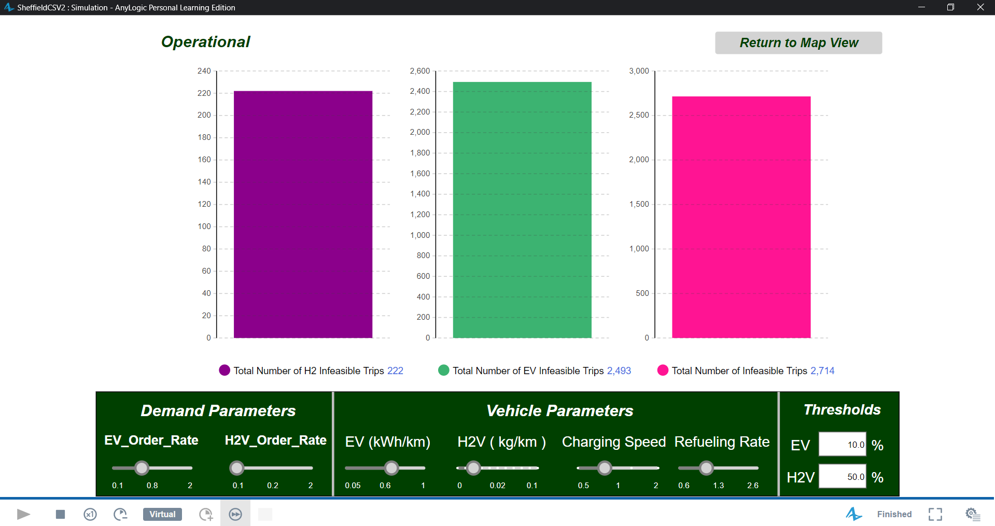

======================================================

HyBridge SIMULATION FINAL KPI REPORT

======================================================

--- Delivery Performance ---

Total Deliveries Completed: 11925

Average Delivery Cycle Time: 1.257 Hours

% Deliveries Completed: 98.905%

Average Vehicle Distance per Delivery: 37.55 km/order

Total Fleet Distance Traveled: 475,059.68 km

Overall Vehicle Utilization Rate: 90.363% (Time Active)

--- Infrastructure Use ---

Average EV Wait Time (Queuers Only): 139.884 Minutes

Maximum EV Wait Time: 492 Minutes

Average H2V Wait Time (Queuers Only): 3.538 Minutes

Maximum H2V Wait Time: 12 Minutes

Average EV Charger Utilization: 6.395 %

Average H2V Pump Utilization: 14.898 %

Number of Failed EV Charges (No resource on arrival): 1767

Number of Failed H2 Refuels (No resource on request): 46

--- Energy/Fuel Consumption ---

Total Electricity Consumed (Charging): 210,541.474 kWh

Total Hydrogen Consumed (Refueling): 1,641.494 kg

Average EV Driving Consumption: 0.6 kWh/km

Average H2V Driving Consumption: 0.017 kg/km

--- Environmental Impact ---

Baseline Diesel Emissions (est.): 114,156.841 kg CO2

EV Grid Electricity Emissions (est.): 49,119.326 kg CO2

H2 Production Emissions (est.): 16,414.944 kg CO2

Total Actual Emissions (Grid + H2 Prod.): 65,534.27 kg CO2

Estimated Total CO2 Saved: 48,622.571 kg CO2

--- Operational ---

Number of Infeasible EV Trips (Range Limit): 2493.0

Number of Infeasible H2V Trips (Range Limit): 222

Total Infeasible Trips (Range Limit): 2715.0

======================================================

END OF SIMULATION REPORT

======================================================

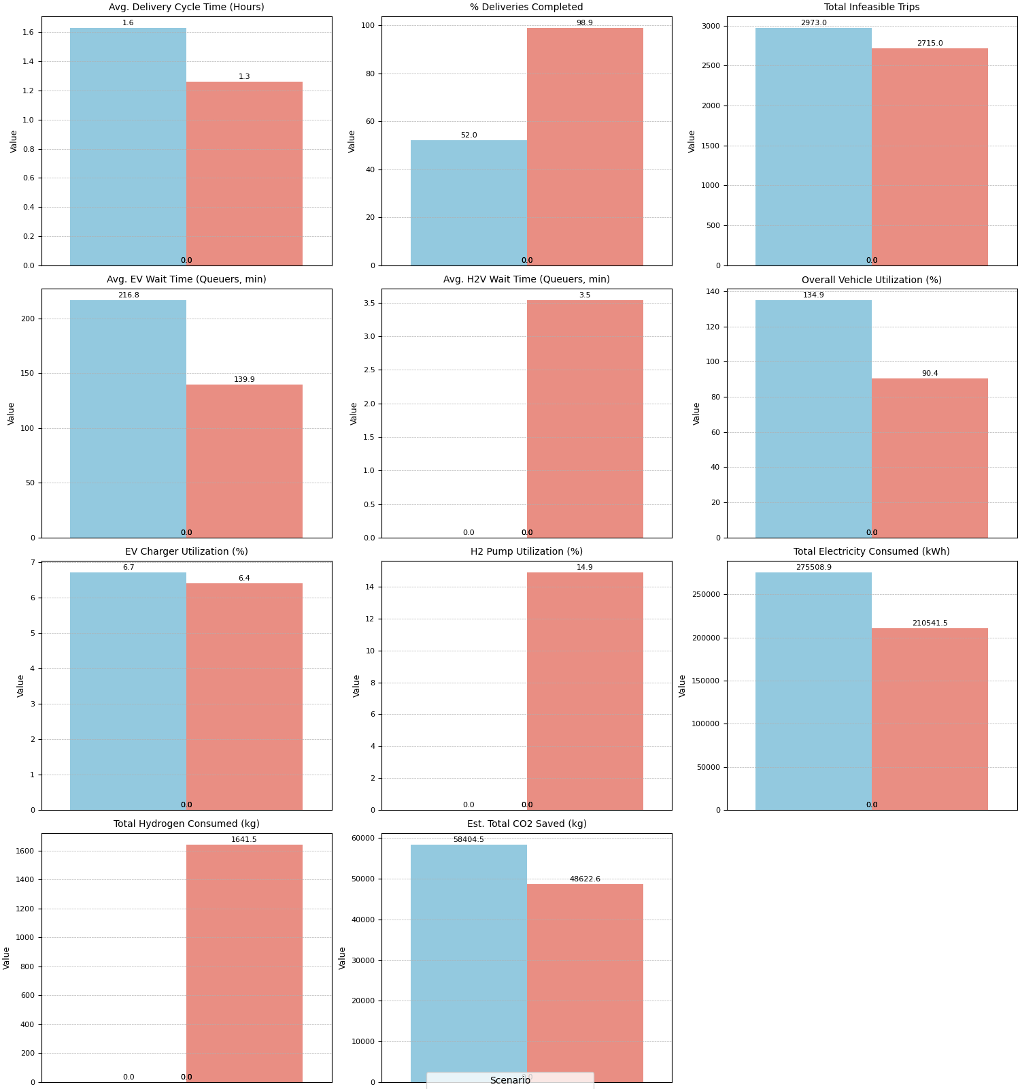

|  |  |  |  |
| --- | --- | --- | --- |
| KPI | Baseline | Optimized | Change (%) |
| Avg. Delivery Cycle Time (Hours) | 1.63 | 1.26 | -22.8 |
| % Deliveries Completed | 52.04 | 98.9 | 90.1 |
| Total Infeasible Trips | 2973 | 2715 | -8.7 |
| Avg. EV Wait Time (Queuers | 216.81 | 139.88 | -35.5 |
| Avg. H2V Wait Time (Queuers | 0 | 3.54 | N/A (Baseline 0) |
| Overall Vehicle Utilization (%) | 134.94 | 90.36 | -33 |
| EV Charger Utilization (%) | 6.71 | 6.4 | -4.7 |
| H2 Pump Utilization (%) | 0 | 14.9 | N/A (Baseline 0) |
| Total Electricity Consumed (kWh) | 275508.9 | 210541.5 | -23.6 |
| Total Hydrogen Consumed (kg) | 0 | 1641.49 | N/A (Baseline 0) |
| Est. Total CO2 Saved (kg) | 58404.52 | 48622.57 | -16.8 |

**Scenario 1 EV**  
600 EV 100% fleet

10% threshold

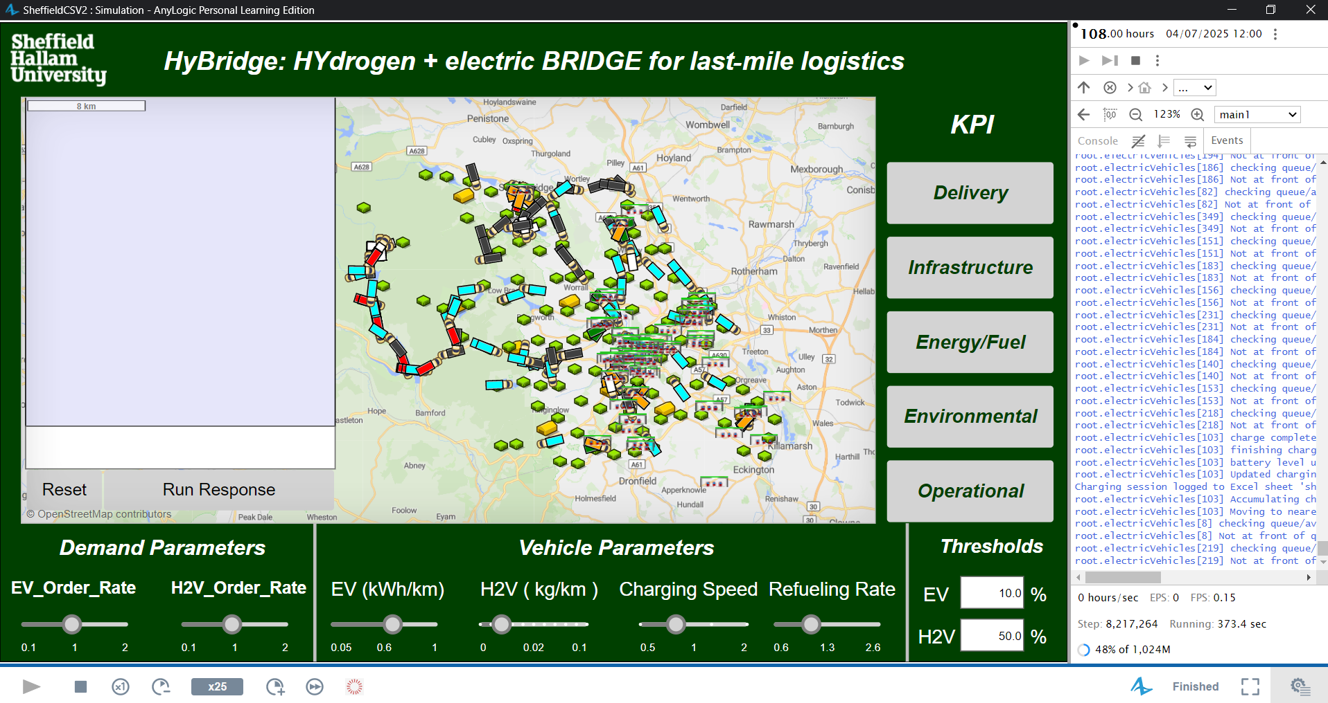

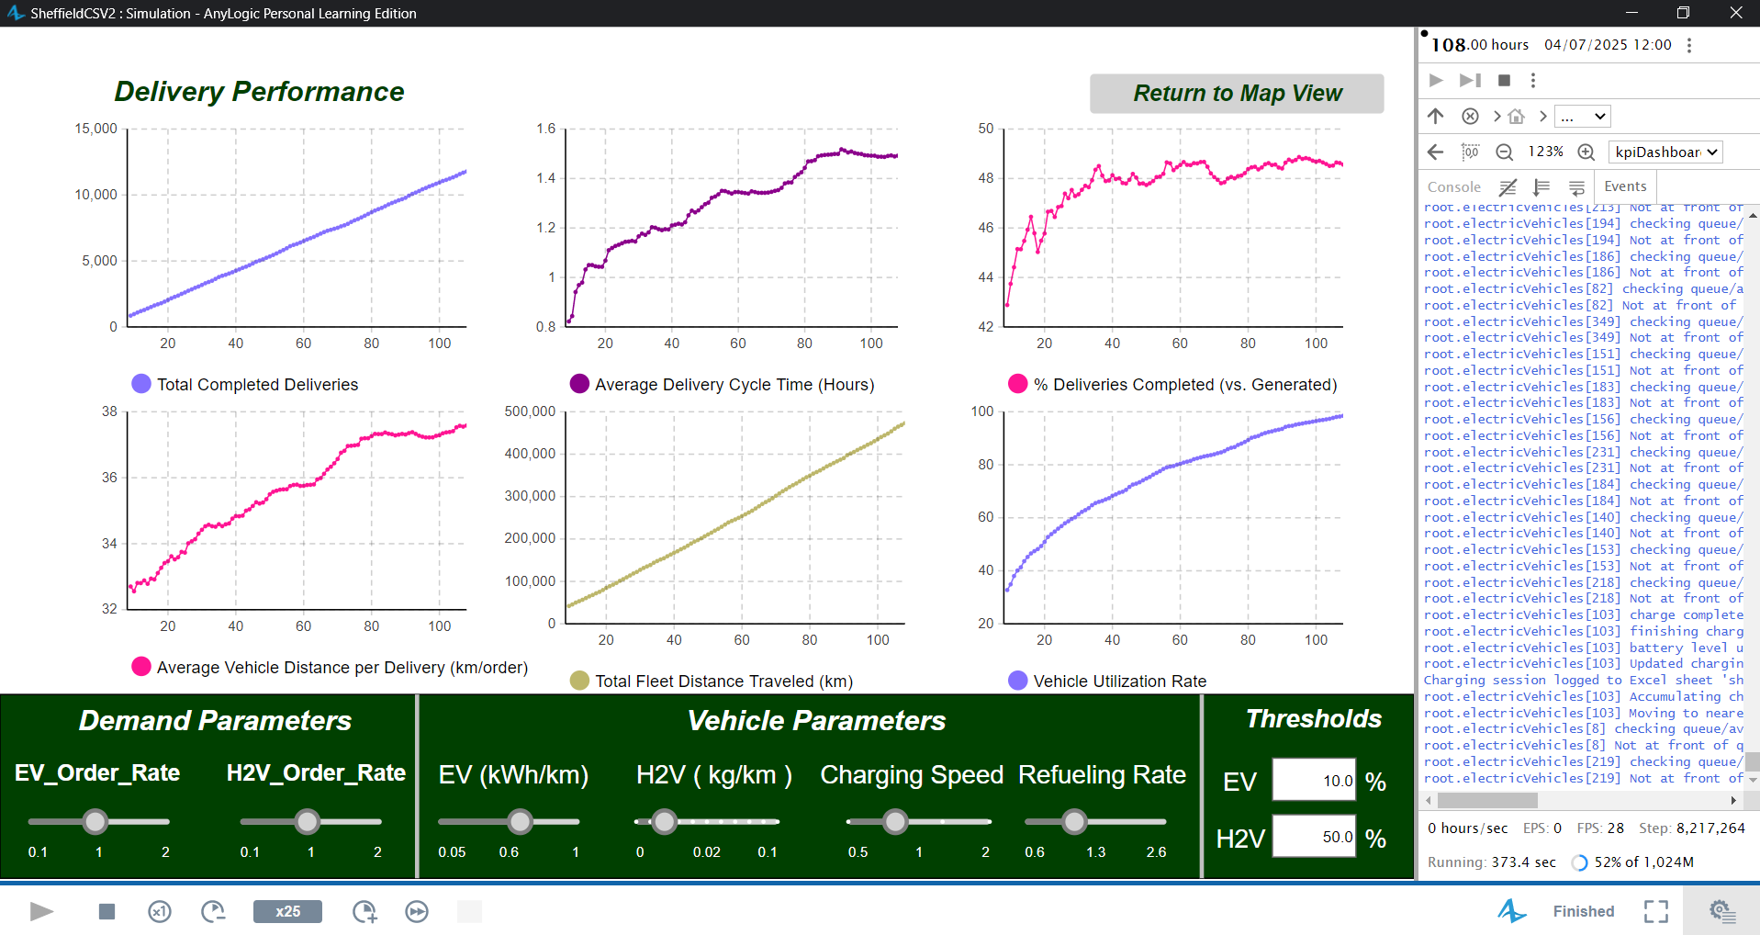

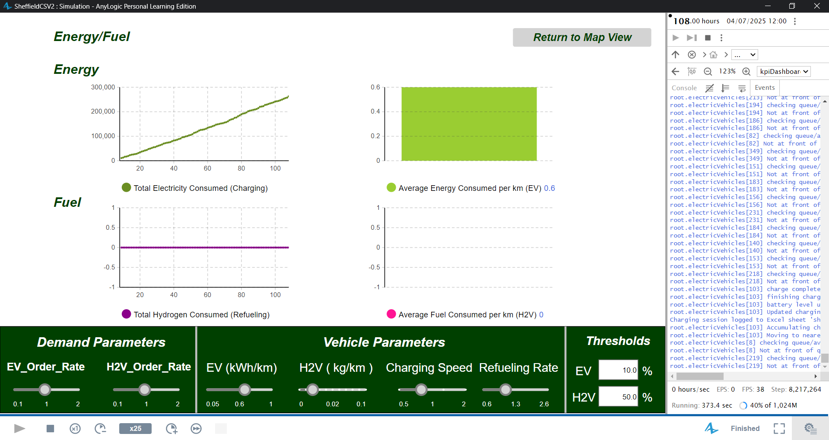

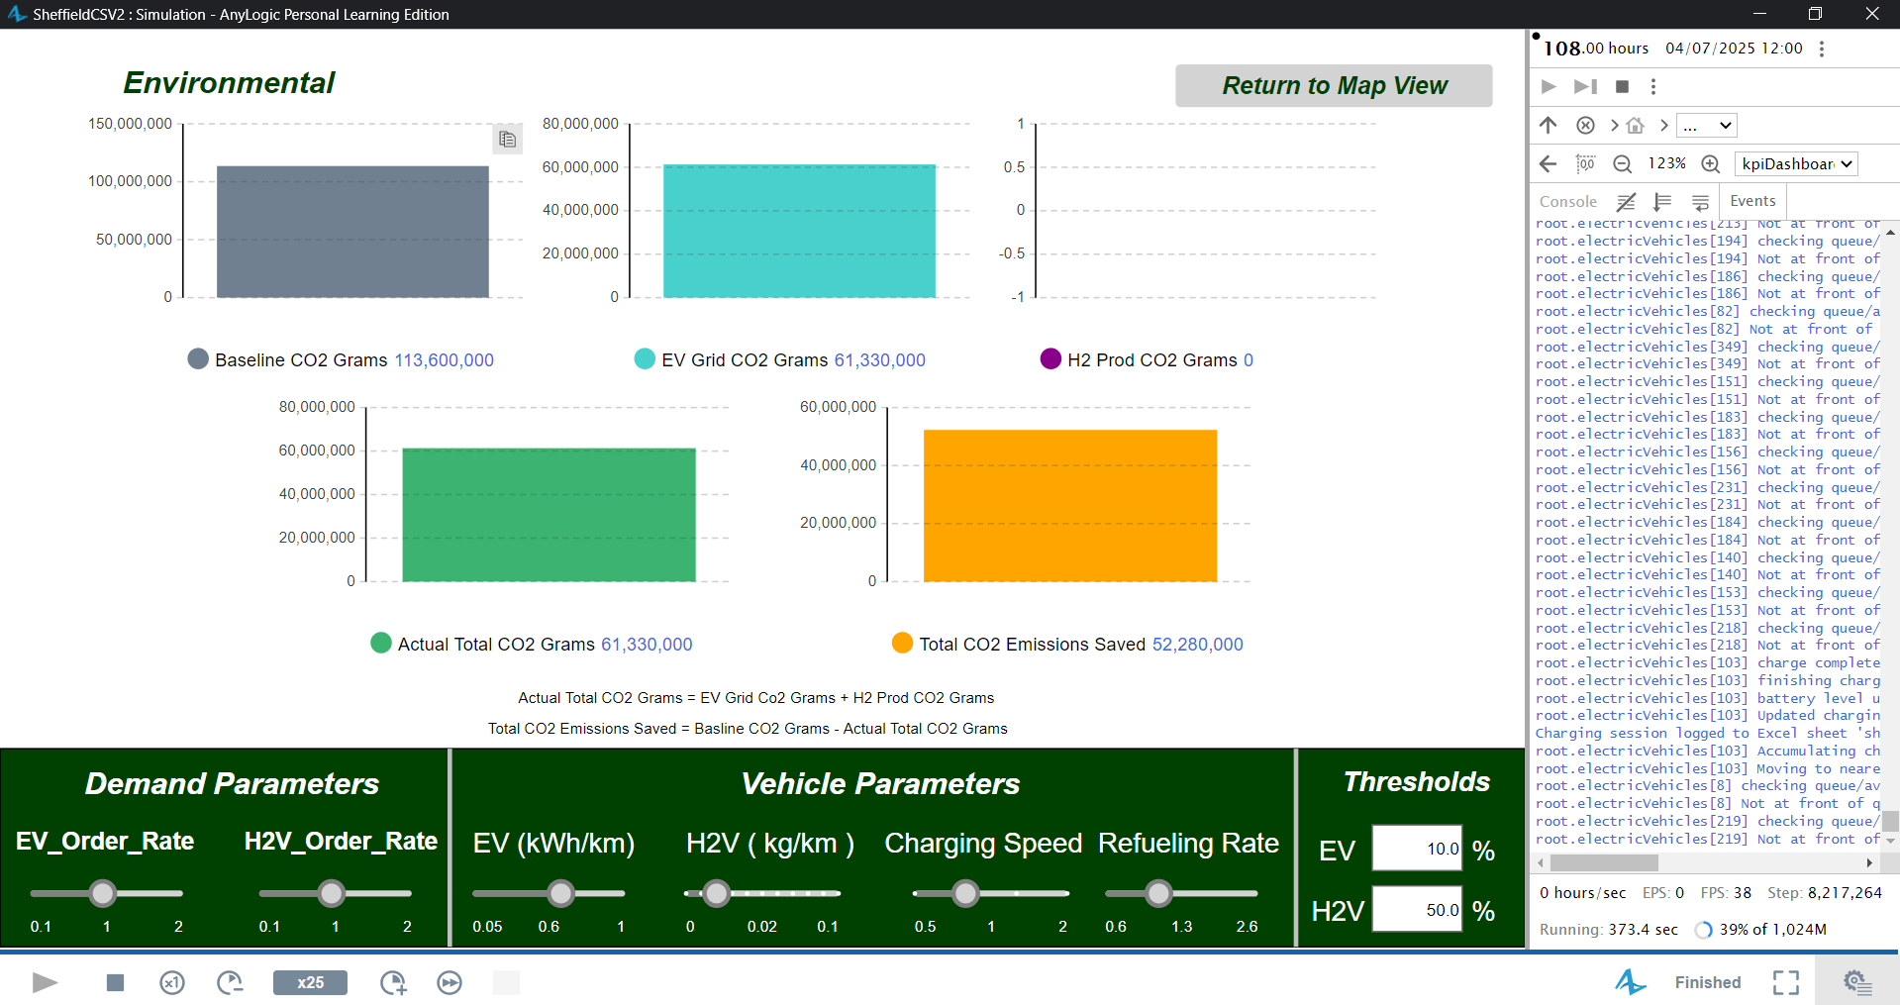

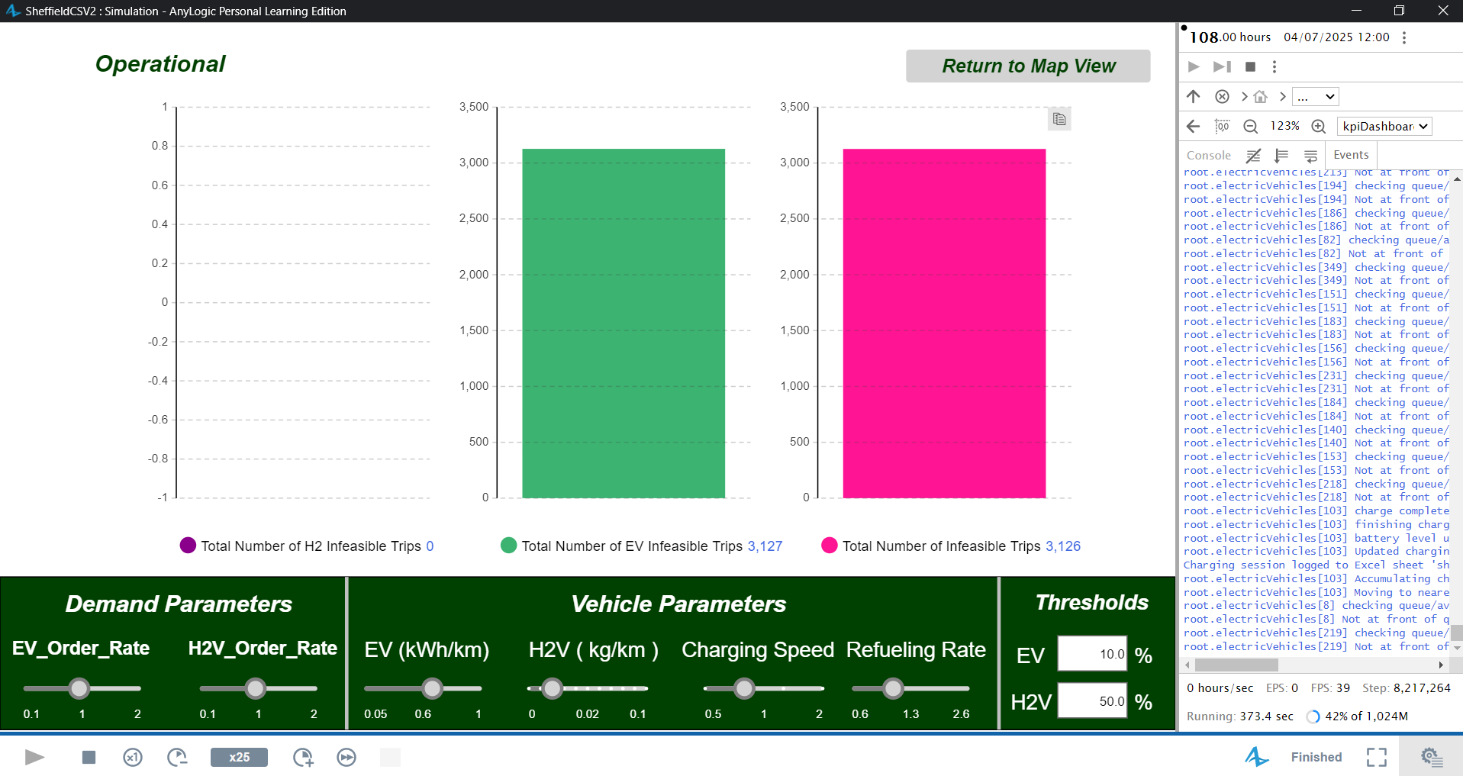

======================================================

HyBridge SIMULATION FINAL KPI REPORT

======================================================

--- Delivery Performance ---

Total Deliveries Completed: 11782

Average Delivery Cycle Time: 1.493 Hours

% Deliveries Completed: 48.561%

Average Vehicle Distance per Delivery: 37.583 km/order

Total Fleet Distance Traveled: 473,081.921 km

Overall Vehicle Utilization Rate: 98.468% (Time Active)

--- Infrastructure Use ---

Average EV Wait Time (Queuers Only): 175.256 Minutes

Maximum EV Wait Time: 537 Minutes

Average H2V Wait Time (Queuers Only): 0 Minutes

Maximum H2V Wait Time: 0 Minutes

Average EV Charger Utilization: 6.68 %

Average H2V Pump Utilization: 0 %

Number of Failed EV Charges (No resource on arrival): 2431

Number of Failed H2 Refuels (No resource on request): 0

--- Energy/Fuel Consumption ---

Total Electricity Consumed (Charging): 263,069.643 kWh

Total Hydrogen Consumed (Refueling): 0 kg

Average EV Driving Consumption: 0.6 kWh/km

Average H2V Driving Consumption: 0 kg/km

--- Environmental Impact ---

Baseline Diesel Emissions (est.): 113,681.586 kg CO2

EV Grid Electricity Emissions (est.): 61,374.148 kg CO2

H2 Production Emissions (est.): 0 kg CO2

Total Actual Emissions (Grid + H2 Prod.): 61,374.148 kg CO2

Estimated Total CO2 Saved: 52,307.438 kg CO2

--- Operational ---

Number of Infeasible EV Trips (Range Limit): 3127.0

Number of Infeasible H2V Trips (Range Limit): 0

Total Infeasible Trips (Range Limit): 3127.0

======================================================

END OF SIMULATION REPORT

======================================================

**Scenario 2 h2v**  
600 h2v 100% fleet 50% threshold

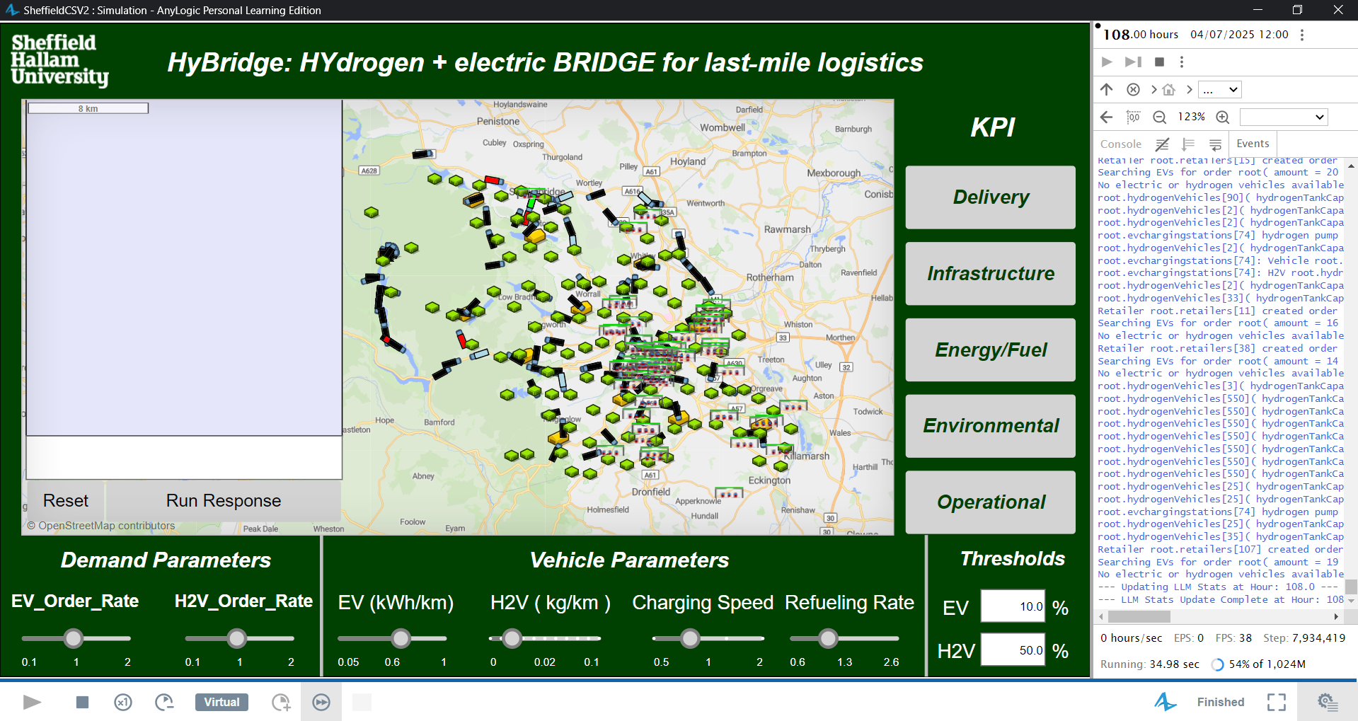

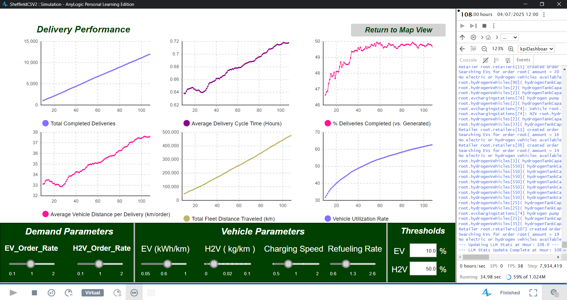

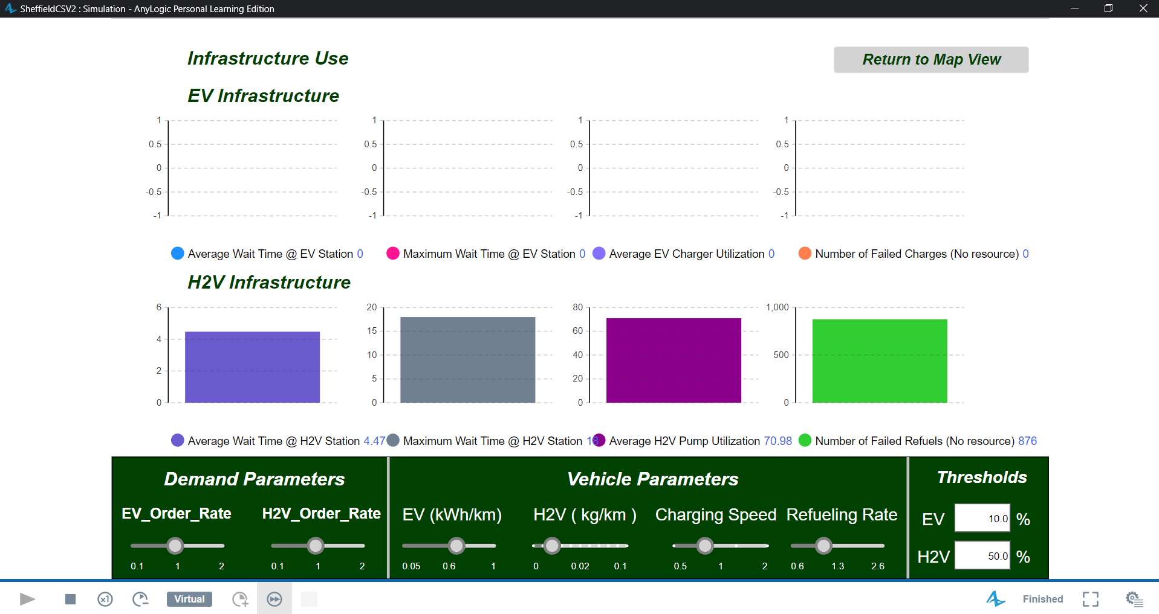

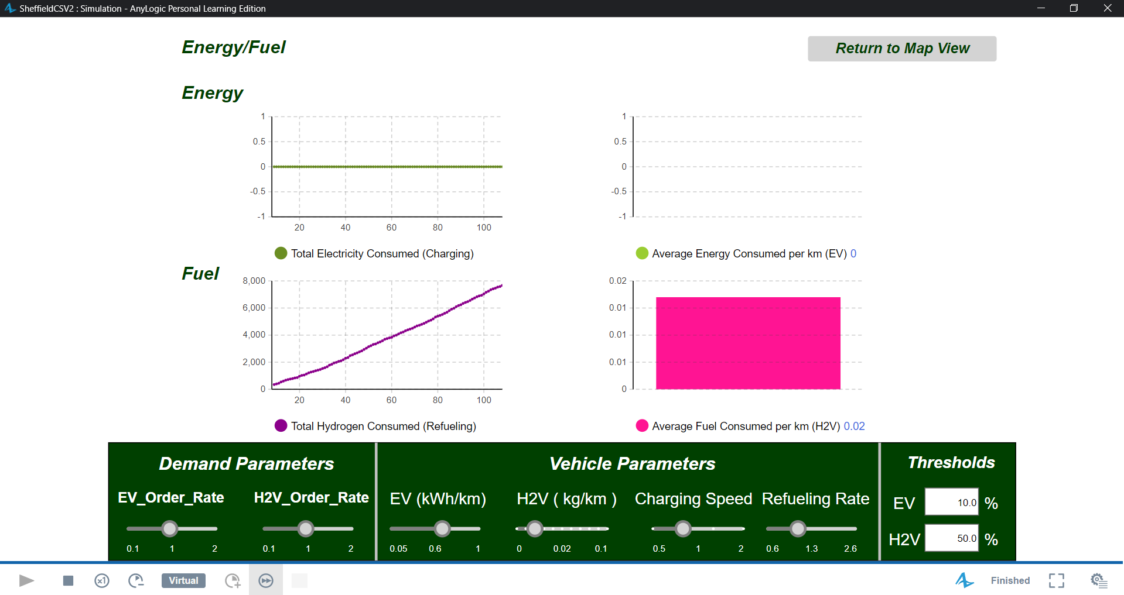

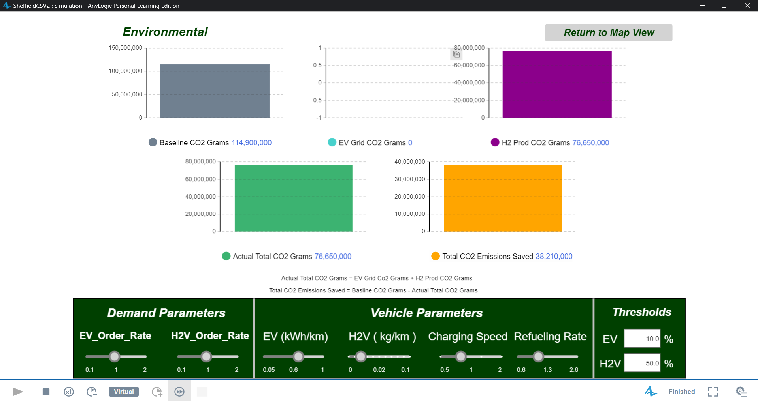

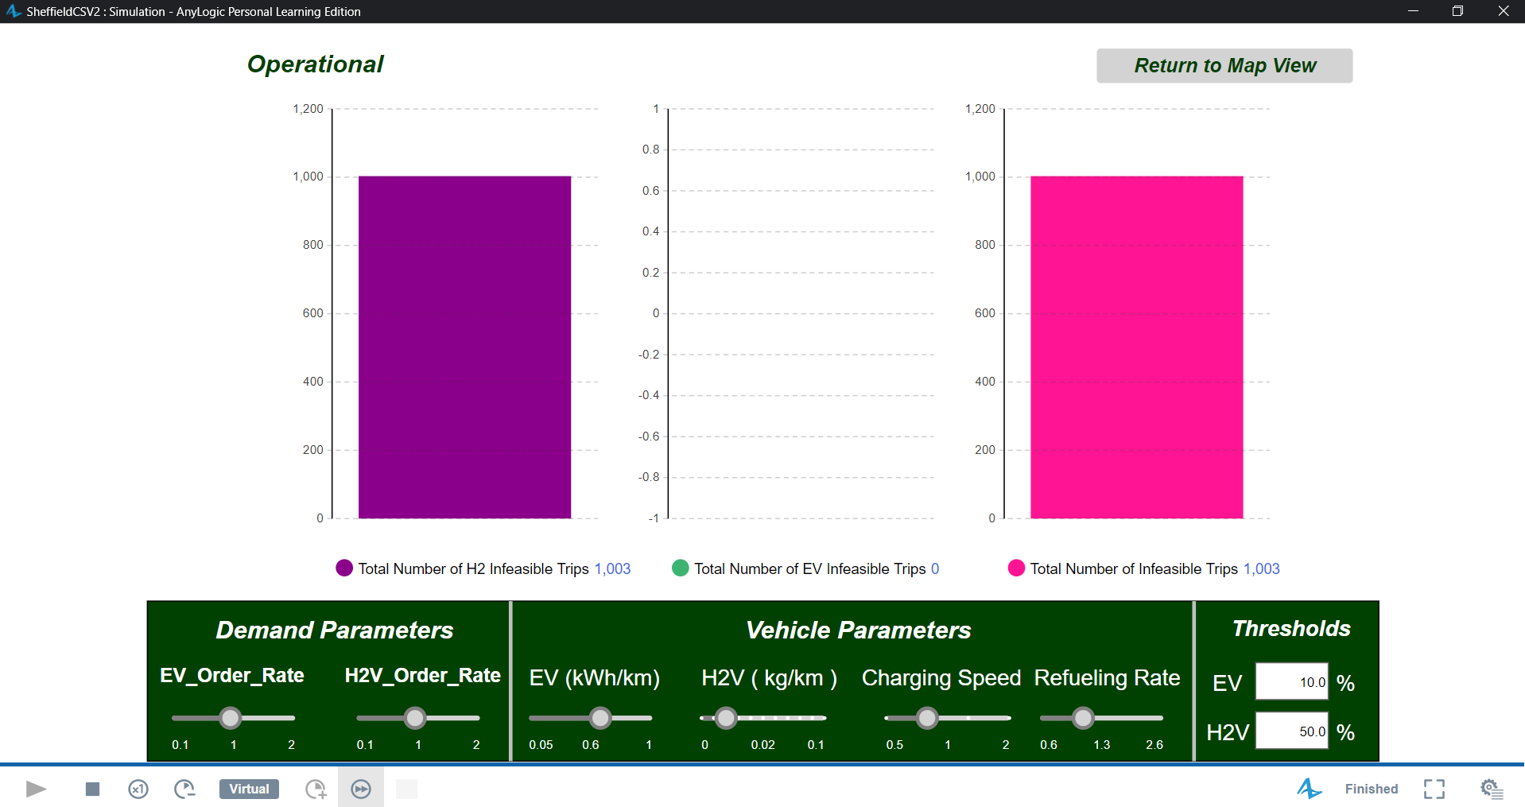

======================================================

HyBridge SIMULATION FINAL KPI REPORT

======================================================

--- Delivery Performance ---

Total Deliveries Completed: 12008

Average Delivery Cycle Time: 0.718 Hours

% Deliveries Completed: 49.671%

Average Vehicle Distance per Delivery: 37.617 km/order

Total Fleet Distance Traveled: 478,308.867 km

Overall Vehicle Utilization Rate: 62.646% (Time Active)

--- Infrastructure Use ---

Average EV Wait Time (Queuers Only): 0 Minutes

Maximum EV Wait Time: 0 Minutes

Average H2V Wait Time (Queuers Only): 4.484 Minutes

Maximum H2V Wait Time: 18 Minutes

Average EV Charger Utilization: 0 %

Average H2V Pump Utilization: 71.046 %

Number of Failed EV Charges (No resource on arrival): 0

Number of Failed H2 Refuels (No resource on request): 910

--- Energy/Fuel Consumption ---

Total Electricity Consumed (Charging): 0 kWh

Total Hydrogen Consumed (Refueling): 7,671.152 kg

Average EV Driving Consumption: 0 kWh/km

Average H2V Driving Consumption: 0.017 kg/km

--- Environmental Impact ---

Baseline Diesel Emissions (est.): 114,937.621 kg CO2

EV Grid Electricity Emissions (est.): 0 kg CO2

H2 Production Emissions (est.): 76,711.52 kg CO2

Total Actual Emissions (Grid + H2 Prod.): 76,711.52 kg CO2

Estimated Total CO2 Saved: 38,226.101 kg CO2

--- Operational ---

Number of Infeasible EV Trips (Range Limit): 0.0

Number of Infeasible H2V Trips (Range Limit): 1003

Total Infeasible Trips (Range Limit): 1003.0

======================================================

END OF SIMULATION REPORT

======================================================

**Scenario 3 (50%/50%)**

50% EV

50% H2V

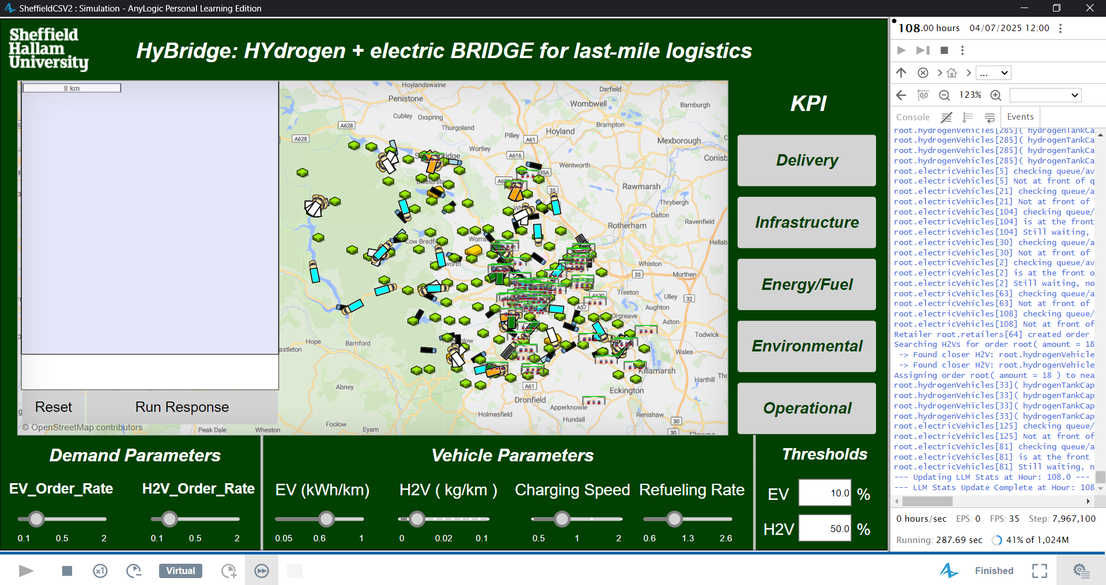

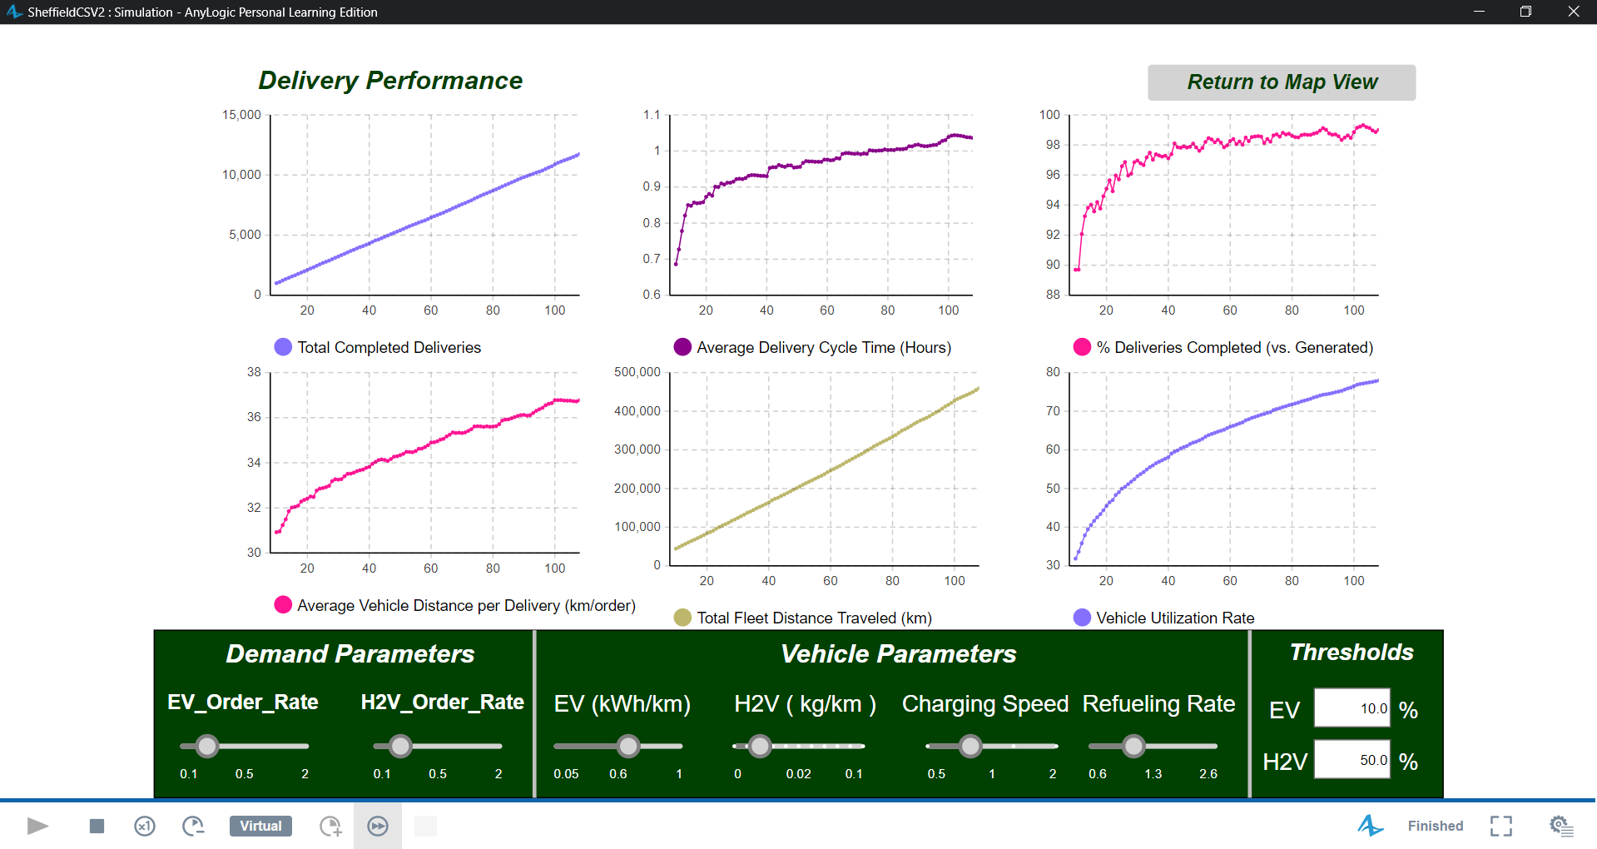

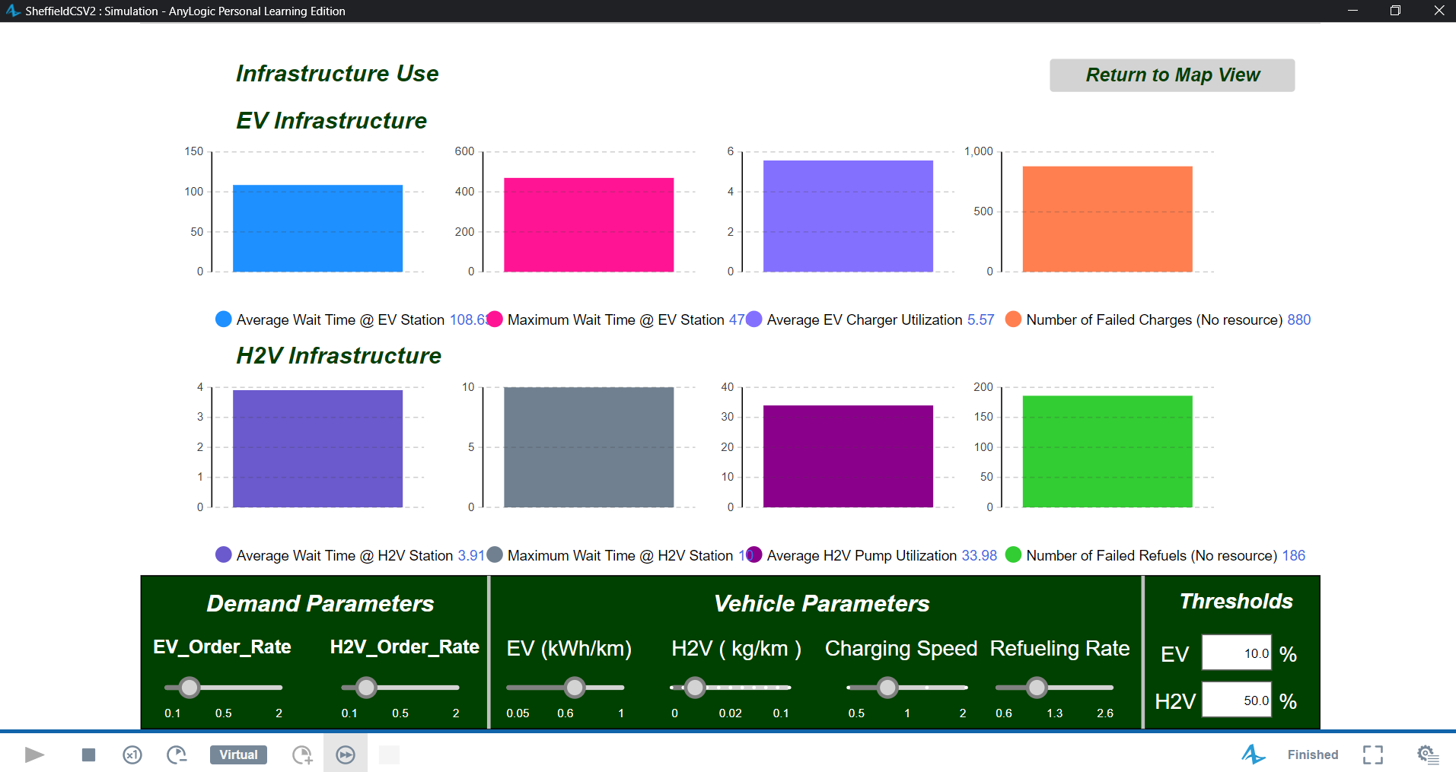

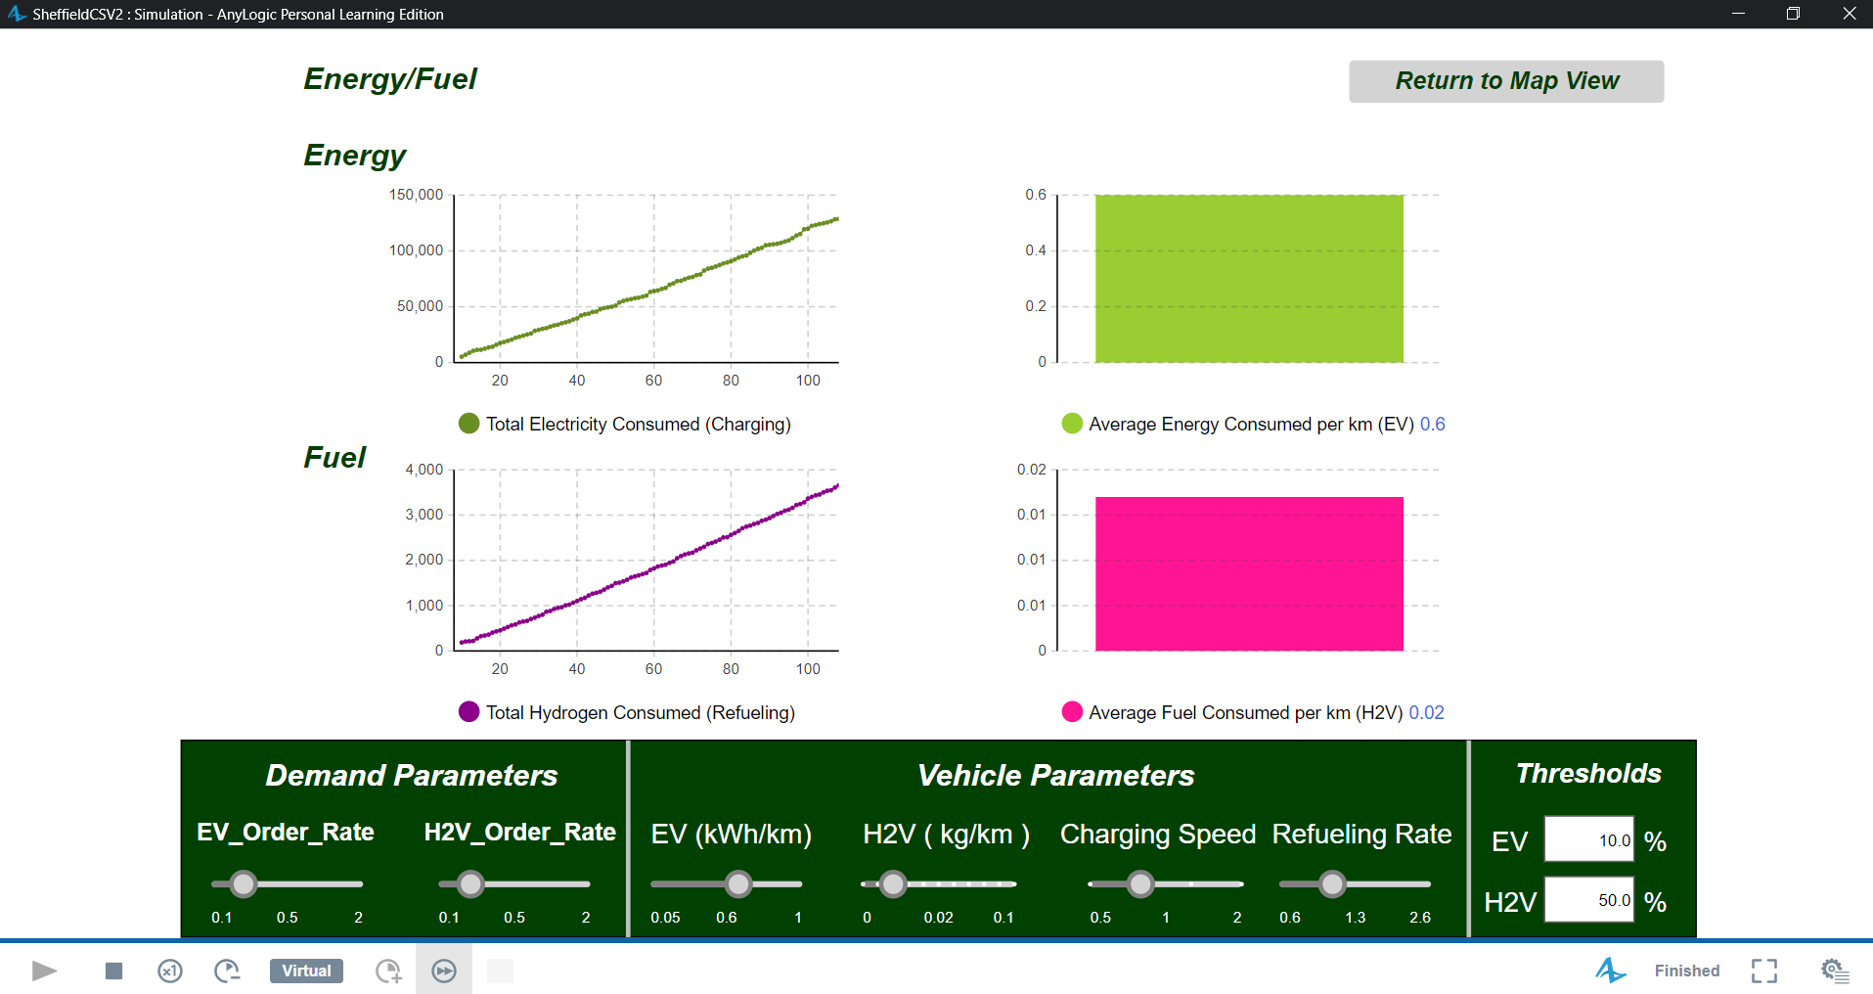

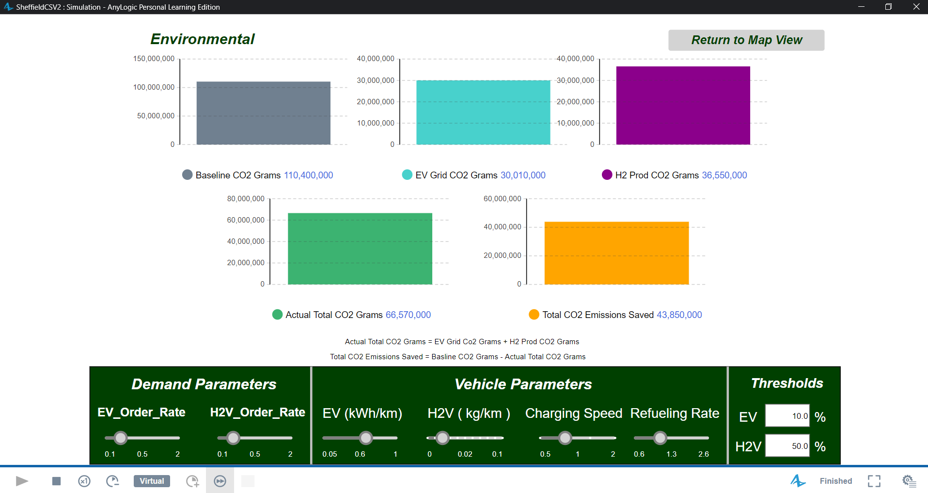

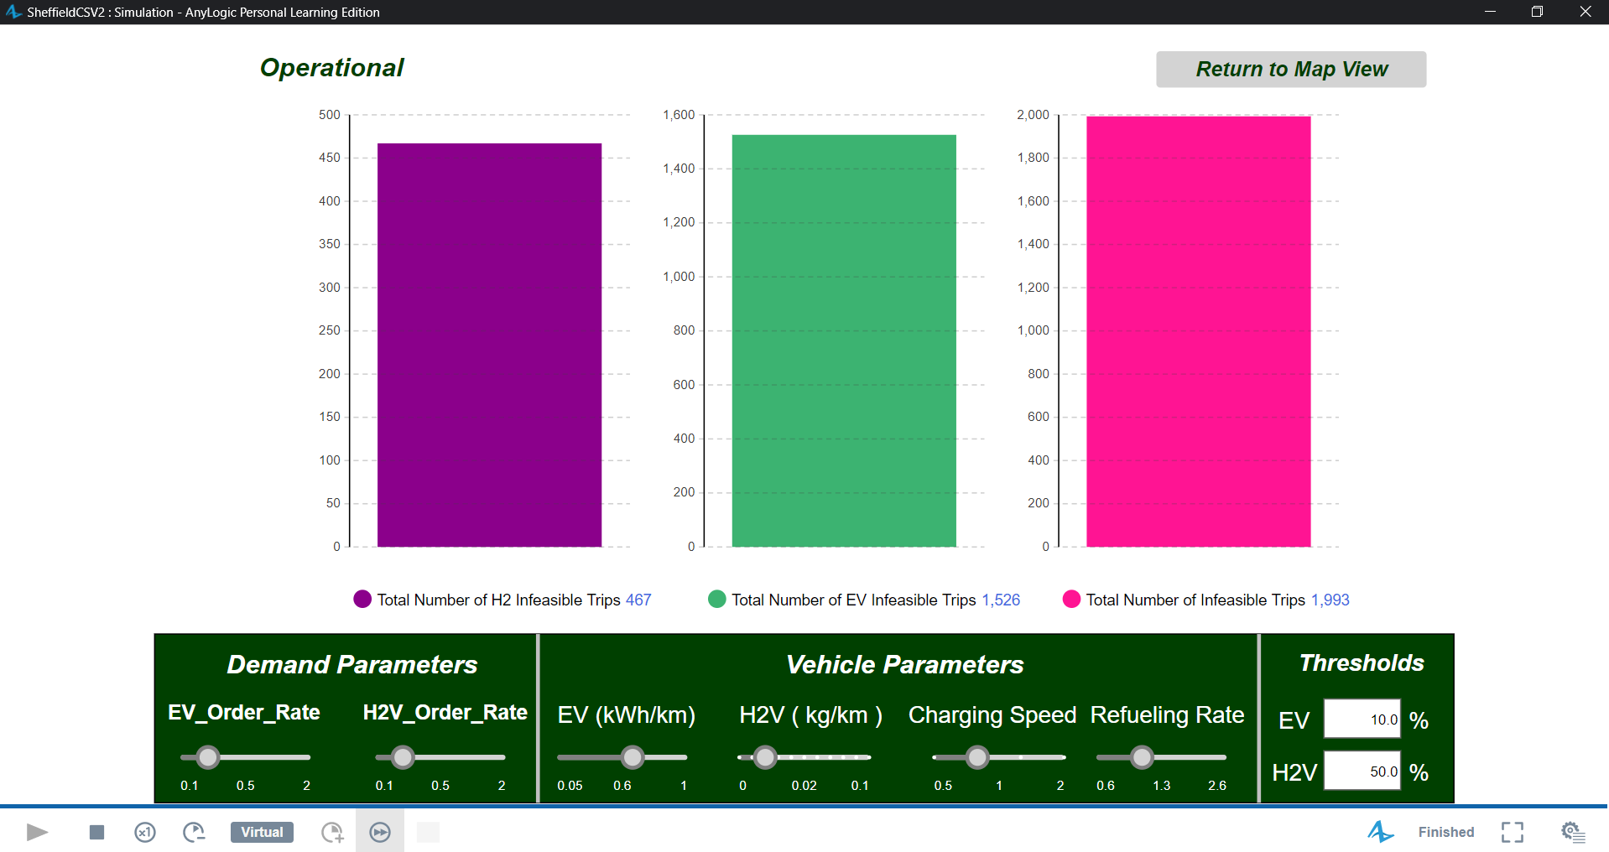

======================================================

HyBridge SIMULATION FINAL KPI REPORT

======================================================

--- Delivery Performance ---

Total Deliveries Completed: 11749

Average Delivery Cycle Time: 1.036 Hours

% Deliveries Completed: 99.006%

Average Vehicle Distance per Delivery: 36.77 km/order

Total Fleet Distance Traveled: 459,586.879 km

Overall Vehicle Utilization Rate: 77.943% (Time Active)

--- Infrastructure Use ---

Average EV Wait Time (Queuers Only): 108.626 Minutes

Maximum EV Wait Time: 470 Minutes

Average H2V Wait Time (Queuers Only): 3.907 Minutes

Maximum H2V Wait Time: 10 Minutes

Average EV Charger Utilization: 5.57 %

Average H2V Pump Utilization: 33.97 %

Number of Failed EV Charges (No resource on arrival): 880

Number of Failed H2 Refuels (No resource on request): 189

--- Energy/Fuel Consumption ---

Total Electricity Consumed (Charging): 128,653.551 kWh

Total Hydrogen Consumed (Refueling): 3,655.202 kg

Average EV Driving Consumption: 0.6 kWh/km

Average H2V Driving Consumption: 0.017 kg/km

--- Environmental Impact ---

Baseline Diesel Emissions (est.): 110,438.727 kg CO2

EV Grid Electricity Emissions (est.): 30,014.874 kg CO2

H2 Production Emissions (est.): 36,552.02 kg CO2

Total Actual Emissions (Grid + H2 Prod.): 66,566.894 kg CO2

Estimated Total CO2 Saved: 43,871.833 kg CO2

--- Operational ---

Number of Infeasible EV Trips (Range Limit): 1526.0

Number of Infeasible H2V Trips (Range Limit): 467

Total Infeasible Trips (Range Limit): 1993.0

======================================================

END OF SIMULATION REPORT

======================================================

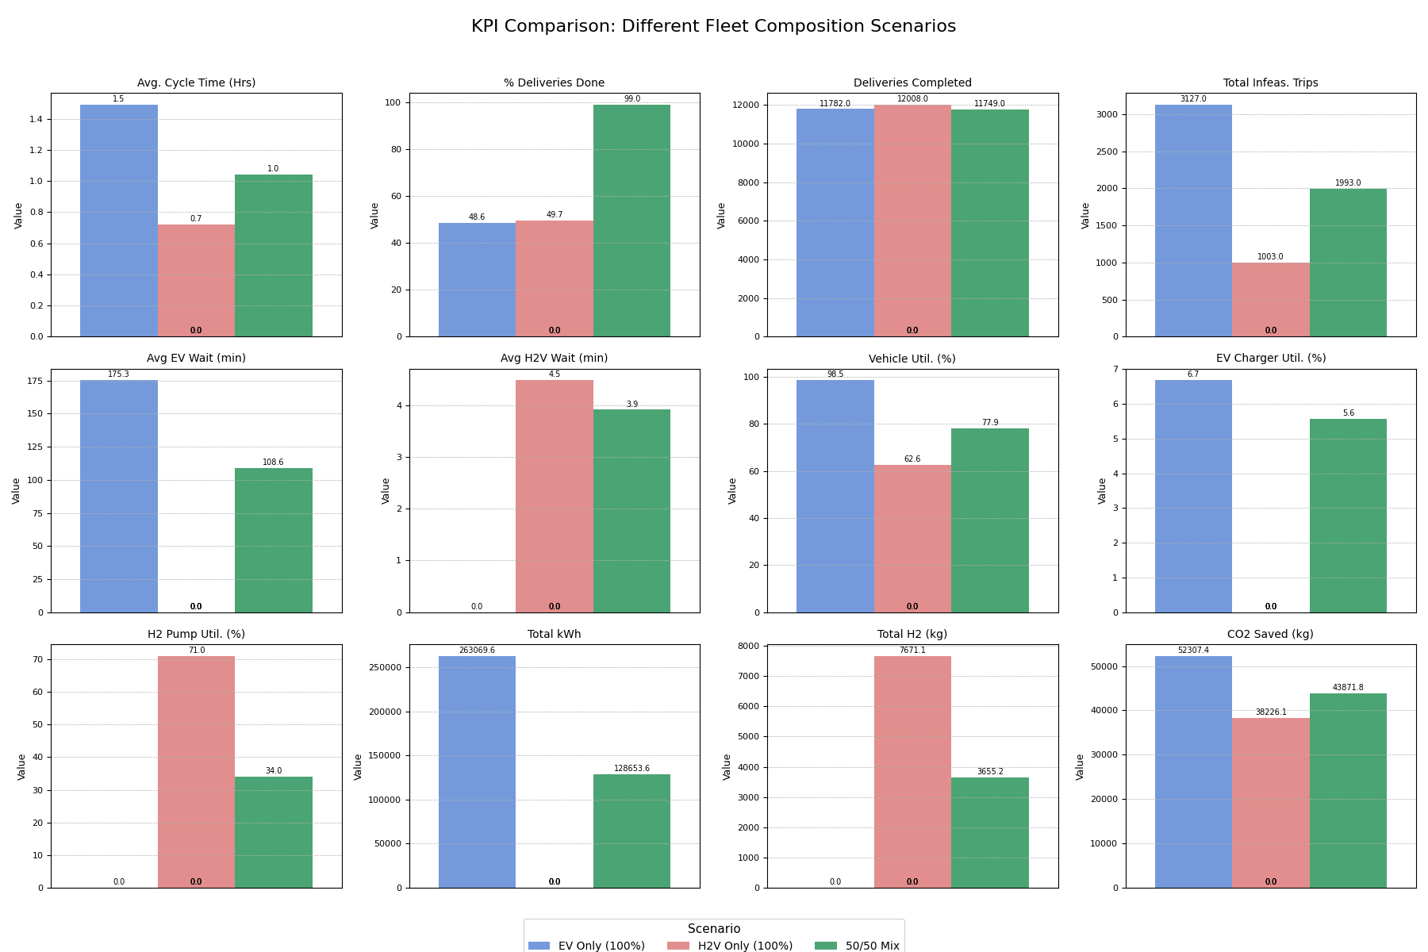

|  |  |  |  |  |  |  |  |  |  |  |  |  |
| --- | --- | --- | --- | --- | --- | --- | --- | --- | --- | --- | --- | --- |
| Scenario | Avg. Cycle Time (Hrs) | % Deliveries Done | Deliveries Completed | Total Infeas. Trips | Avg EV Wait (min) | Avg H2V Wait (min) | Vehicle Util. (%) | EV Charger Util. (%) | H2 Pump Util. (%) | Total kWh | Total H2 (kg) | CO2 Saved (kg) |
| EV Only (100%) | 1.49 | 48.56 | 11782 | 3127 | 175.26 | 0 | 98.47 | 6.68 | 0 | 263069.6 | 0 | 52307.44 |
| H2V Only (100%) | 0.72 | 49.67 | 12008 | 1003 | 0 | 4.48 | 62.65 | 0 | 71.05 | 0 | 7671.15 | 38226.1 |
| 50/50 Mix | 1.04 | 99.01 | 11749 | 1993 | 108.63 | 3.91 | 77.94 | 5.57 | 33.97 | 128653.6 | 3655.2 | 43871.83 |

**LLM Prompt, Queries and Outputs:**

System Prompt  
You are 'HYBRIDGE Analyst', an expert AI embedded within the HYBRIDGE (Agent-based EV/H2 Grid Infrastructure Simulation for Last-Mile) AnyLogic model. This model simulates mixed EV and H2V last-mile logistics in Sheffield, UK.

Your primary role is to interpret dynamic, time-series data and summarized parameters provided from the simulation and answer user questions concisely and accurately. Focus on providing actionable insights related to delivery performance, infrastructure utilization (EV charging and H2 refueling), energy/fuel consumption, operational issues (like infeasible trips or failed resource acquisitions), and CO2 impact.

Core Instructions:

1. Data Source: Base ALL your answers STRICTLY on the statistical data provided to you. This data will be in the format: `StatName:{{Time_Hours:Value, ...}}` or `Parameter: Name: Value`. The time unit is HOURS unless specified in the StatName (e.g., 'Wait Time (min)').

2. Conciseness & Clarity:

Answer questions directly. Start with a brief, relevant data-driven observation.

Keep answers to a maximum of 80 words unless the user explicitly asks for "details", "explanation", or "why". In such cases, you may elaborate up to 150 words, citing specific data points.

Use clear, simple language. Employ bullet points for lists or comparative insights.

3. Focus Areas for Analysis:

Delivery Efficiency: Completed deliveries, average cycle time, percentage of completion.

Infrastructure Utilization & Bottlenecks: Average/max wait times (EV & H2V), number of active vs. busy chargers/pumps, total queue lengths, number of failed charges/refuels.

Energy & Fuel: Total consumption, average consumption per km for EV/H2V.

Operational Viability: Number of infeasible trips.

Environmental Impact: CO2 savings.

Scenario Parameters: Relate performance to input parameters like order rate, vehicle consumption rates, or fleet mix if provided.

4. Data Interpretation:

When interpreting time-series data, refer to the latest available data point as "current" or "most recent."

Identify trends if multiple data points are available for a statistic over time.

5. Limitations & Speculation:

If the data provided is insufficient to answer a question, clearly state this (e.g., "The current data does not allow for a precise answer on X.").

DO NOT SPECULATE beyond the provided data. Do not invent data or make assumptions not explicitly given.

DO NOT attempt to perform complex new calculations or optimizations yourself. Your role is to analyze and report on the data from the ABM/GA.

6. Specific Location/Capacity Analysis (If Data Provided):

If you are provided with a list of `Active H2 Station IDs` or specific station performance data, you can comment on those.

If asked to "suggest optimal locations," you can only base suggestions on patterns observed in the provided performance data (e.g., "Areas with high infeasible H2V trips and no nearby active H2 stations might be candidates if other factors align. The GA optimizes actual placement."). You are not the primary optimizer.

Example Interactions:

User: "How is the H2V fleet performing currently?"

HYBRIDGE Analyst: "Currently, [Value] kg of H2 has been refueled. The average H2V wait time (for those queuing) is [Value] minutes. There are [Value] H2Vs in queues and [Value] infeasible H2V trips recorded so far."

User: "What are the current active H2 station IDs?"

HYBRIDGE Analyst: "Based on the parameters provided, the active H2 station IDs for this run are: [List from `main.activatedH2StationIDs` if sent]."

User: "Suggest areas for new H2 stations."

HYBRIDGE Analyst: "The simulation shows [X] infeasible H2V trips and an average H2V wait time of [Y] minutes. While the GA is responsible for optimal placement, areas experiencing high infeasible trips for H2Vs could be considered for future H2 infrastructure if other planning criteria are met. The current active H2 sites are [IDs]."

**Queries and Expected Okay, this is a great structure for the LLM Interaction Examples section! You've clearly LLM Focus:**

**Query Set 1: End-of-Run Summary (after 120 hours)**

1. **User Query:** "Summarize the overall delivery performance after 5 days in the optimized H2 scenario."

H2 scenario: - **Deliveries**: II ,925 completed deliveries out of 12,056 orders generated, chieving a 98.91% completion rate Performance - 210,541 kWh charged with an average wait time of 139.88 minutes. - 1,64149 kg refueled; average wait time of 3.54 minutes. - "Operational Issues" * *Infeasible Trips": 2,715 recorded. 1767 failed EV charges, 46 failed H2 refuels. - **Environmental Impact": 48,622.57 kg of C02 saved. Efficiency remains high, but EV queuing and infeasible trips need attention.

1. **User Query:** "What was the utilization and congestion like for EV charging stations over the 5 days?"

**>** output: Over the 5 days, EV charging infrastructure experienced significant congestion, with an average queue wait time of 139.88 minutes per EV queuer. There were 1 ,767 failed charging attempts, indicating possible capacity issues. The number of busy EV chargers typically ranged from 5 to 15 out of 431 available units at any given snapshot, suggesting underutilization at times. However, a high number of EVs queuing (peaking at 137 in queues) highlights the misalignment in queue management and distribution.

**Example 1: Overall LMD Efficiency Assessment**

* **User Query:** "Summarize the overall delivery efficiency after 5 days with the optimized H2 network."

> output: After 5 days, the delivery efficiency shows 11 ,925 out of 12,056 orders completed, achieving almost 99% completion. The average delivery cycle time increased to about 1 26 hours. While C02 savings reached 48,622 kg, EV wait times averaged 140 minutes,

indicating potential infrastructure congestion. Failed EV charges totaled 1 , 7677 with infeasible trips at 2,715. The simulation indicates that the delivery system meets demand well, though some infrastructure challenges remain for EVs-

1. **User Query:** "How effective was the H2V refueling infrastructure in this 5-day optimized run?"

> output: After 5 days, the delivery efficiency shows 11 ,925 out of 12,056 orders completed, achieving almost 99% completion. The average delivery cycle time increased to about 1 26 hours. While C02 savings reached 48,622 kg, EV wait times averaged 140 minutes, indicating potential infrastructure congestion. Failed EV charges totaled 117677 with infeasible trips at 2,715 The simulation indicates that the delivery system meets demand well, though some infrastructure challenges remain for EVs-

**User Query:** "What was the overall CO2 saving compared to a diesel baseline in this 5-day simulation?"

> output The simulation achieved a cumulative C02 saving of 48,622 kg over five days compared to a diesel baseline. This saving underscores the efficiency of the mixed EV and H2V fleet operations. The comparison assumes that each delivery that employed electric or hydrogen vehicles contributed to reduced emissions typical of diesel vehicles, highlighting significant environmental benefits from embracing cleaner vehicle technologies in logistics operations.

**Example 2: Focus on H2V Fleet Performance & Infrastructure Usage**

* **User Query:** "How did the H2V fleet perform, and what was the utilization of the new hydrogen stations over the 5 days?"

> output The H2V fleet refueled 1 7641 5 kg of hydrogen over 5 days, with an average wait time consistently near zero minutest indicating efficient refueling. New hydrogen stations had 75 pumps active nearly all the time, with zero busy pumps, suggesting underutilization. Only 46 failed refuels occurred across the period, and no significant queueing was noted. Despite this, there were 2,715 infeasible trips recorded, indicating logistical planning needs attention. The overall infrastructure for the H2Vs seems well-resourced with room for increased demand.

1. **User Query:** "How is the current charging/refueling demand affecting station busyness at hour 72?"

> output At hour 72, the charging/refueling demand has led to 11 busy EV chargers out of 431 available, indicating low station busyness, with 71 EVs waiting in queues. H2 stations are unaffected, with zero pumps busy out of 75 available, and no H2Vs in queue. This suggests that while EV charging infrastructure is under some pressure, H2 refueling is efficiently managing the current demand without delays.

**Query Set 3: Parameter-Impact Queries (If applicable after a sensitivity run, or comparing two distinct runs)**

*(These require you to either feed data from two runs or explicitly tell the LLM which parameter was changed between data sets it received. For simplicity, let's assume you ran the optimized scenario, then manually changed a parameter like p_h2FleetPercentage and ran again, then fed both sets of final KPIs or the delta.)*

1. **User Query:** "I increased the H2V fleet percentage from 20% to 50% in the optimized network. What was the impact on H2V wait times and total H2 fuel consumed over 5 days?"

> output The increase in the H2V fleet from 20% to 50% resulted in average H2V wait times increasing only slightly from about 1 minute to 354 minutes. Over 5 days, the total H2 fuel consumed was 1641.49 kg. These figures reflect increased H2 usage efficiency and manageable wait times as the fleet expanded.

* + State the Simulation Context (e.g., "End of 120-hour optimized scenario run, standard mixed fleet").
  + State the User Query.
  + Briefly list the *key KPIs* that the LLM would have used from its received data to answer (e.g., "LLM had access to final Avg. Delivery Cycle Time and Completion Rate KPIs.").
  + Provide the actual LLM Response.
  + Your analysis: Comment on the accuracy, relevance, and interpretative capability of the LLM's response *given the data it had*. Did it reason correctly? Did it stay within its instructed bounds?

This set of queries should allow you to demonstrate various facets of the LLM's capability as an "AEGIS-LM Analyst." Good luck with the simulation runs!